
MINISTRY OF EDUCATION AND TRAINING

FPT UNIVERSITY

Capstone Project Document
Build a website provide service for delivering meal designed and prepared by talent chefs to customer

Group 6
Group Members | Nguyễn Thành Nhân – Leader – SE60677  Lê Quang Khương Duy – Member – SE60752  Trương Quang Bảo – Member – 60575  Phạm Văn Duy – Member – SE60634
Supervisor | Lâm Hữu Khánh Phương
Ext Supervisor | N/A
Capstone Project code | EWC

Ho Chi Minh, 01/2014

1 Table of Contents
1 Table of Contents 2
3. System Requirement Specifications …………………………………………………………………………………………......4
3.1. User Requirement Specification 4
3.2. System Requirement Specification 4
3.2.1. External Interface Requirement 10
3.2.1.1. User Interfaces 10
3.2.1.2. Hardware Interfaces 10
3.2.1.3. Software Interfaces 10
3.2.1.2. Communication Protocol 10
3.2.2. Functional Requirements 11
3.2.2.1. List Dish in Menu 11
3.2.2.2. Add to cart 13
3.2.2.3. Confirm order 16
3.2.2.4. Order dish Error: Reference source not found
3.2.2.5. Manage dish 18
3.2.2.5.1. Show dish in back-end system 18
3.2.2.5.2. Create dish 20
3.2.2.5. Manage Produce Session 23
3.2.2.6.1. Show dish of today menu 35
3.2.2.6.2. Generate produce session 37
3.2.2.6.3. Create produce session 39
3.2.2.6.4. View produce session history 42
3.2.2.6. Manage menu 45
3.2.2.7.1. List menu Error: Reference source not found
3.2.2.7.2. Create menu Error: Reference source not found
3.2.2.7.3. View detail menu Error: Reference source not found
3.2.2.7.4. Edit menu Error: Reference source not found
3.2.2.7.5. Suggest menu Error: Reference source not found
3.2.2.7. Manage supplier 66
3.2.2.8.1. Create supplier 66
3.2.2.8.2. Edit supplier 69
3.2.2.8.3. Delete supplier 73
3.2.2.8.4. Restore supplier Error: Reference source not found
3.2.2.8.5. Show supplier 75
3.2.2.9. Manage User 78
3.2.2.9.1 Show User Error: Reference source not found
3.2.2.9.2 Create Staff 89
3.2.2.9.3 Create Chef 93
3.2.2.9.4 Edit score of skill of Chef 97
3.2.2.9.5 Deactive User Error: Reference source not found
3.2.2.9.6 Active User Error: Reference source not found
3.2.3. Non-Functional Requirements 99
3.3. Entity Relationship Diagram 102

3. System Requirement Specifications

3.1. User Requirement Specification
Eat With Chef provides features for customers to browse daily menu, add dishes they would like to their cart, make order and payment online. On the other hand, customers can follow Chefs they like, system will inform to customer list dish that chefs prepare in tomorrow menu and when chefs public new dishes. System help Staff, Admin and Chef manage three main processes: Business process, Produce process and Delivery process.
- In Business process: The system help staff to manage customer’s orders, create and publish daily menu, manage ingredients and suppliers.
- In Produce process: Chef can use the system to create produce session that create numbers of dish items. In create process; chef can update suppliers for ingredients in dishes. When finished cooking session, they can print QR code store information of dish items that customer can tracking.
- In Delivery process: Staffs can matching dishes in customer’s orders with dishes item in produce session. Then system will calculate to suggest groups of orders assign to delivery man deliver to customer.
In addition, system supports Admin to manage system accounts and roles. Chef can use the system to create their dishes with description and cooking guides.

3.2. System Requirement Specification
- System overview:
System provides features for food ecommerce system that users can connect and interact with each other, staff of company can manage company ecommerce business.
In overview, system will divide into two main develop systems: Front-end system interact with customer, support customer to order dishes; Back-end system support Staff, Chef and Admin manage the business.
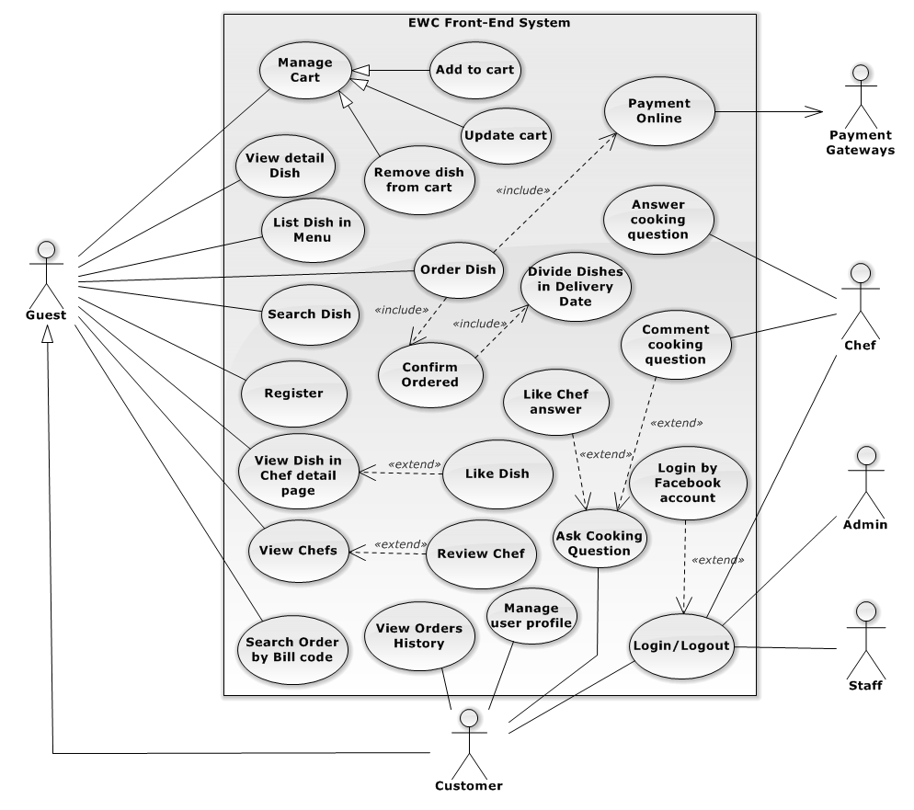
Figure 3-1 System Overview Front-end use case diagram
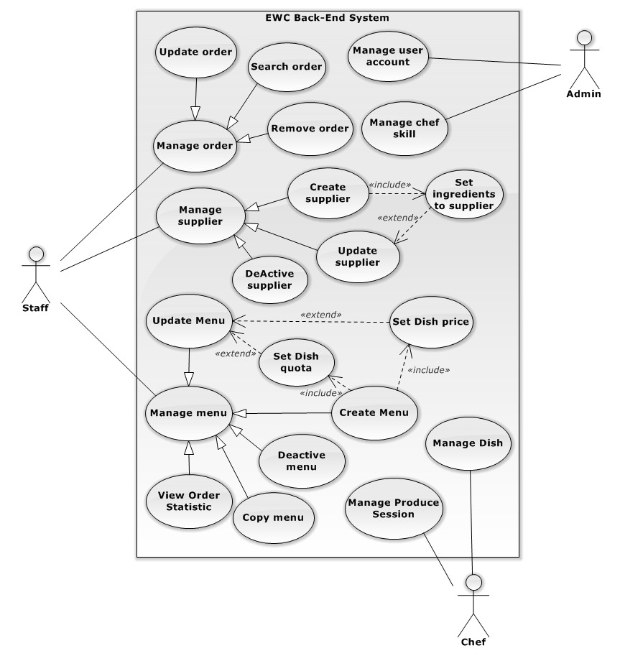
Figure 3-2 System Overview Back-end use case diagram
No. | Actor | Description
1 | Guest | User who does not have an account or has not logged in system.
2 | Customer | User who is the customer of Eat With Chef system, who logged to system and use the services system provide for customer. Main action of customer is order Dishes designed and prepare by talent Chef.
3 | Payment Gateway | API of online payment systems allow user to pay online. In current context system support Paypal.
4 | Mobile Application | Application for scan QR code to traceability.
5 | Staff | Employee of Ecommerce company.
6 | Admin | Administrator of the system.
7 | Chef | User who logged to system as Chef role. They design Dishes and manage produce sessions.

- Program flow:
- Order Dish
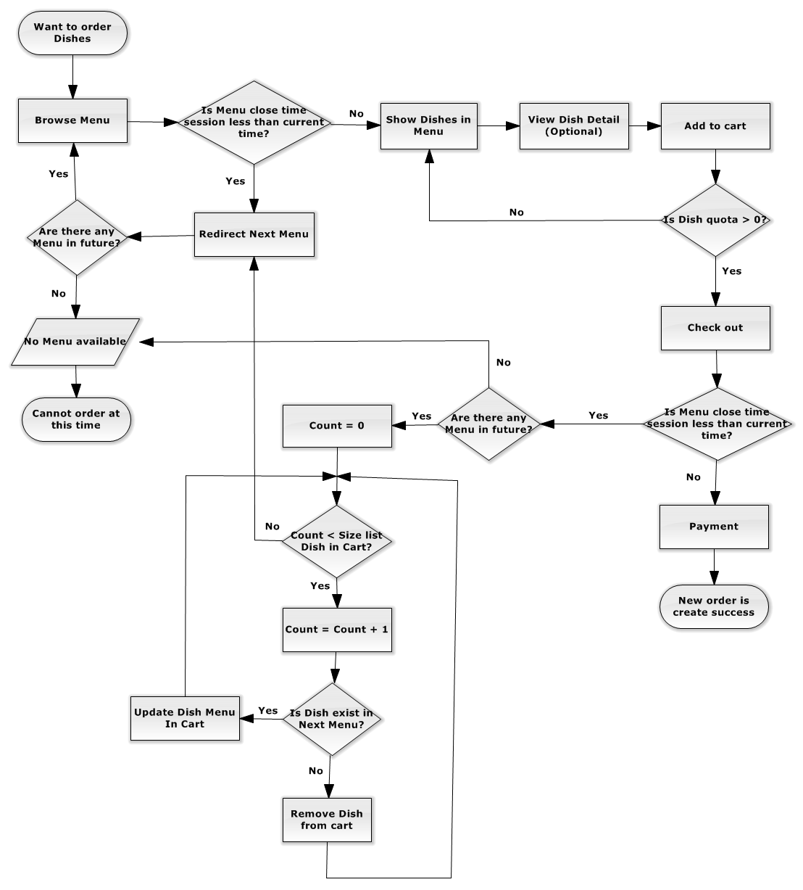
Figure 3-3 Flow for order Dish
- Publish Menu
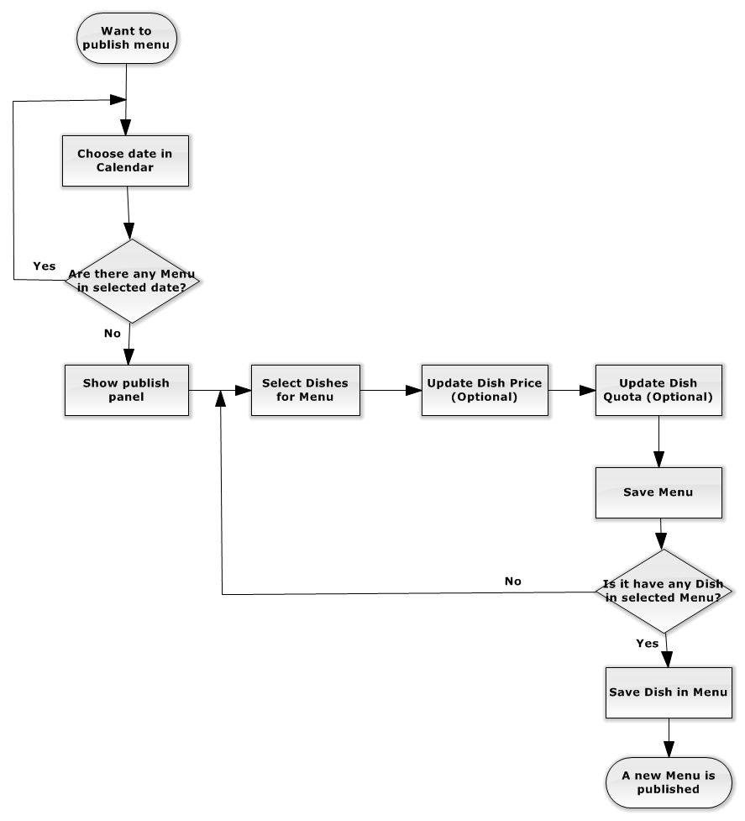
Figure 1-4 Flow for publish Menu
- Create Produce Session
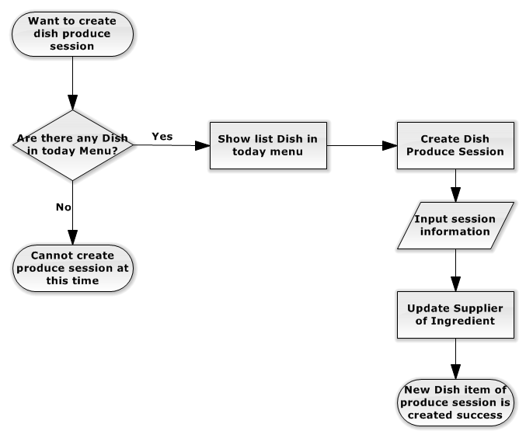
Figure 3-5 Flow for create produce session

3.2.1. External Interface Requirement

3.2.1.1. User Interfaces
The graphic user interface of system is clear, easy to interaction and do not annoy customer.
The error, warning message must be make clear easy to understand and error message does not disturb customer.

3.2.1.2. Hardware Interfaces
The system will use the standard hardware and data communications resources of a standard server computer.

3.2.1.3. Software Interfaces
System work well on Chrome browser and support core function in Firefox with Resolution (1024*768) or bigger and support Javascript and HTML5.

3.2.1.2. Communication Protocol
Website using HTTP protocol for communication between the web browser and the web server.

3.2.2. Functional Requirements

3.2.2.1. List Dish in Menu
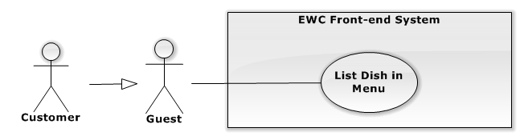
Figure 3-3 List Dish in Menu use case diagram

USE CASE SPECIFICATION
Use-case No. | UC001 | Use-case Version | 2.0
Use-case Name | List Dish in Menu
Author | Nguyễn Thành Nhân
Date | 20/01/2014 | Priority | High
Actor:
Guest, Customer.
Summary:
Guest and Customer can view Dishes in menu to Add to cart and Check out for order.
Goal:
The purpose of List Dish in Menu use case is list Dishes in menu for Guest and Customer to order.
Triggers:
Customer wants to view Dishes in menu to Add to cart and Check out for order.
Customer browses homepage or click on menu in list future menu.
Preconditions:
System must call CheckCloseTimeSession method to check menu close time session that satisfy the business before list dish.
Post Conditions:
Success:
- All available Dishes in menu are listed and allow customer to add to cart and check out for order.
Failure:
- The Customer is guided to Error page
Main Success Scenario:
Actor Actions | System Response
- Customer browses homepage. | - System get current time and get menu by apply time.  - If there is no menu available by current time, system will show message “Chưa có thực đơn cho hôm nay”.  - If there is at least one menu, system will chose first or default menu, then compare current time with menu’s close time session:  + If current time is greater than menu’s close time session, system will display message “Đã hết thời gian đặt món hôm nay” then search for nearest future menu and redirect Customer to that menu with List Dishes in menu.  + If current time is less than menu’s close time session, system will show list dishes in menu to Customer.  [Exception 1]  [Alternative 1][ Alternative 2]

Alternative Scenario:
Actor Actions | System Response
[Alternative 1]  - Customer click on one of menus listed in future menu list in menu bar.  [Alternative 2]  - No dishes in menu to list. | - System show list dishes in menu.  - Show message “Chưa có món ăn cho thực đơn”.

Exceptions:
Actor Actions | System Response
[Exception 1]  - System fails to load data. | - Show Error page.

Relationships:
- None
Business Rules:
- System display dishes in menu when current time less than menu’s close time session.

3.2.2.2. Add to cart
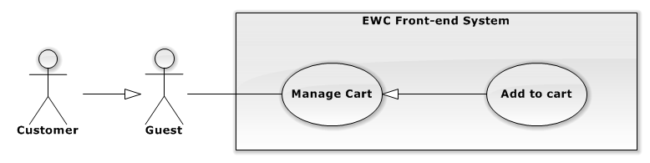
Figure 3-4 Add to cart use case diagram

USE CASE SPECIFICATION
Use-case No. | UC002 | Use-case Version | 2.0
Use-case Name | Add to cart
Author | Nguyễn Thành Nhân
Date | 22/01/2014 | Priority | High
Actor:
Guest, Customer.
Summary:
Guest and can add Dish to their cart for order.
Goal:
The purpose of Add to cart is allow customer add Dish they would like in today or future menus to their cart that satisfy system business for store number of Dishes in period of time then check out for order later.
Triggers:
Customer wants to add Dish they would like in today or future menus to their cart for order.
Customer click Add to cart in menu’s page or detail dish page.
Preconditions:
Dish quota is not reach limited.
Current time is less than current menu close time session.
Post Conditions:
Success:
- Dish is added to cart store at client local storage.
Failure:
- Dish quota rich limited.
- Dish is in menu in the pass.
- Current time is greater than current menu close time session.
Main Success Scenario:
Actor Actions | System Response
- Customer click “Thêm” button in menu’s page. | - System check dish quota in database.  - If dish quota reaches limited, system will show message “Đã hết số lượng đặt món ăn này hôm nay”.  - If dish quota is available, system will check menu close time session.  + If current time is greater than menu close time session, system will show message “Đã hết thời gian đặt món hôm nay” then search for nearest future menu and redirect customer to that menu with List Dishes in menu.  + If current time is less than menu close time session, system will add dish to cart store at client local storage and replace dish image with number of that dish in cart.  [Alternative 1][ Alternative 2]

Alternative Scenario:
Actor Actions | System Response
[Alternative 1]  - Customer click dish detail in menu page.  - Customer click Add to cart in detail page.  [Alternative 2]  - Customer goes to dish detail page by input URL to browser.  - Customer click Add to cart. | - System show dish detail.  - System check dish quota in database.  - If dish quota reaches limited, system will show message “Đã hết số lượng đặt món ăn này hôm nay”.  - If dish quota is available, system will check menu close time session.  + If current time is greater than menu close time session, system will show message “Đã hết thời gian đặt món hôm nay” then search for nearest future menu and redirect customer to that menu with List Dishes in menu.  + If current time is less than menu close time session, system will add dish to cart store at client local storage and replace dish image with number of that dish in cart.  - System will check dish menu apply date.  - If menu apply date is less than today. System get dish URL and check this in future menu.  + If dish is exist in future menu, system will redirect to detail page of first menu in future and allow customer to add to cart.  + If dish does not exist in future menu, system will show message “Món ăn chưa sẵn sàng để đặt. Vui lòng chọn món khác.” and redirect customer to today menu page.  - If menu apply date is greater or equal today, system will show dish detail page and allow customer add to cart.  - System check dish quota in database.  - If dish quota reaches limited, system will show message “Đã hết số lượng đặt món ăn này hôm nay”.  - If dish quota is available, system will check menu close time session.  + If current time is greater than menu close time session, system will show message “Đã hết thời gian đặt món hôm nay” then search for nearest future menu and redirect customer to that menu with List Dishes in menu.  + If current time is less than menu close time session, system will add dish to cart store at client local storage and replace dish image with number of that dish in cart.

Exceptions:
None
Relationships:
- List Dish in Menu
Business Rules:
- System allow customer add dish of current or future menu.
- System allow customer add dish which quota is available to cart.
- System allow customer add dish to cart when current is less than menu close time session.

Confirm order
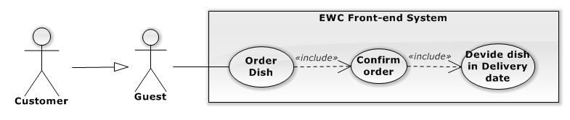
Figure 3-5 Confirm order use case diagram
USE CASE SPECIFICATION
Use-case No. | UC003 | Use-case Version | 2.0
Use-case Name | Confirm order
Author | Nguyễn Thành Nhân
Date | 24/01/2014 | Priority | High
Actor:
Guest, Customer
Summary:
Guest and Customer go to check out page then list dishes in cart is divided by delivery date then show for customer to confirm.
Goal:
The purpose of Confirm order is show list dishes in cart which are divided by delivery date for customer to confirm before submit order.
Triggers:
Customer want to view dishes they have added to cart to confirm before submit order.
Customer browses url “domain name/thanh-toan” or click “THANH TOÁN” in cart region.
Preconditions:
There is at least one dish in cart for order.
Post Conditions:
Success:
- All Dishes in cart are divided by delivery date and list for customer to confirm.
Failure:
- If there is no any dish in Cart, system will show message “Chưa có món ăn trong giỏ hàng.” Then redirect customer to today menu page.
- The Customer is guided to Error page if fail to load data.
Main Success Scenario:
Actor Actions | System Response
- Customer click on “THANH TOÁN” button in cart region. | - System will check cart in local storage.  - If cart is empty, system will show message “Chưa có món ăn trong giỏ hàng” then redirect customer to today menu page.  - If cart is not empty, system will divide dishes in cart by delivery date and show to customer.  [Exception 1]  [Alternative 1]

Alternative Scenario:
Actor Actions | System Response
[Alternative 1]  - Customer goes to check out page by URL “domain name/thanh-toan”. | - System will check cart in local storage.  - If cart is empty, system will show message “Chưa có món ăn trong giỏ hàng” then redirect customer to today menu page.  - If cart is not empty, system will divide dishes in cart by delivery date and show to customer.

Exceptions:
Actor Actions | System Response
[Exception 1]  - System fails to load data. | - Show Error page.

Relationships:
- Order dish.
Business Rules:
None.

Manage dish
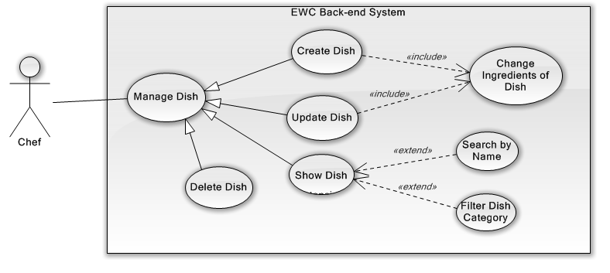
Figure 3-7 Manage dish use case diagram

Show dish in back-end system
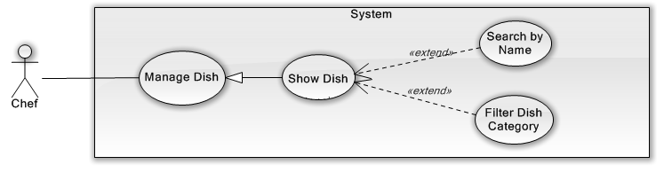
Figure 3-8 Show dish in back-end system use case diagram
USE CASE SPECIFICATION
Use-case No. | UC005 | Use-case Version | 2.0
Use-case Name | Show Dish
Author | Lê Quang Khương Duy
Date | 20/01/2014 | Priority | High
Actor:
Chef
Summary:
Chef views all Dishes in EWC service.
Goal:
The purpose of Show Dish use case is allowed Chef to request for viewing all Dish in the system.
Triggers:
Chef wants to view Dish for EWC service.
Chef clicks on “Món Ăn” menu on menu bar.
Preconditions:
User must be logged-in as Chef-role.
Post Conditions:
Success:
- Dishes are shown in Dish grid view of “Quản Lý Món Ăn” screen match with search conditions.
Failure:
- The Chef is presented with an error message on screen.
Main Success Scenario:
Actor Actions | System Response
- Chef clicks on “Món Ăn” menu on menu bar.  - Chef chooses filter options or type keyword for search. | - Redirect to “Quản Lý Món Ăn” page include:  - Search section: includes  “Tìm kiếm”[Keyword: TextBox, default is Empty]  Two filter for Dish Category[Dish Category Filter: Drop-down list, default is “Tất cả danh mục”] and sorting[Sort Filter: Drop-down list, default is “Tên: A đến Z”]  Paging control [Paging: list of Action Link, default is set at page 1].  - Dish Panel section: includes result Dishes for search conditions.  - Dish Panel display list of suitable dishes for filter options. [Exception 1]

Alternative Scenario:
None
Exceptions:
Actor Actions | System Response
[Exception 1]  - System fails to load data. | - Show message “Lỗi xảy ra. Xin thử lại.”

Relationships:
- Manage Dish
Business Rules:
None

Create dish
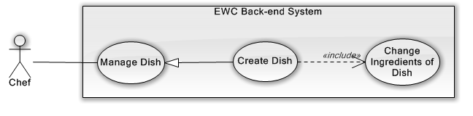
Figure 3-9 Create dish use case diagram
USE CASE SPECIFICATION
Use-case No. | UC006 | Use-case Version | 2.0
Use-case Name | Create Dish
Author | Lê Quang Khương Duy
Date | 21/01/2014 | Priority | High
Actor:
Chef
Summary:
Chef create new Dish
Goal:
The purpose of Create Dish use case is allowed Chef to request for creating new Dish in the system.
Triggers:
Chef wants to create Dish for EWC service.
Chef clicks on “Món Ăn” menu on menu bar to access “Quản Lý Món Ăn” page and then click “Tạo Mới” button.
Preconditions:
User must be logged-in as Chef-role.
Post Conditions:
Success:
- Chef creates new Dish successful.
Failure:
- The Chef is presented with an error message on screen.
Main Success Scenario:
Actor Actions | System Response
- Chef clicks on “Tạo Mới” button  - Chef fills the information for the Dish and click “Tiếp tục” button or choose “Chọn nguyên liệu” tab.  - Chef drags and drops Ingredient to the right container then clicks on “Thêm Mới” button.[Alternative 1] [Alternative 2] | - “Thêm Món Ăn” panel shows up on the center of the screen, includes:  - “Thông tin món ăn” tab:  “Tên”[Name: Textbox, max length: 100, require]  “Danh Mục”[Dish Category: Drop down list, includes all Dish Category]  “Giá”[Price: Textbox, require]  “Mô tả” [Description: text area, string]  “Cách nấu” [Cooking Guide: text area, string]  “Tag” [Tag: Textbox with multiple select, send request for searching existed Tag]  “Hình ảnh” [Image: image picker, include a file input and a file-preview label]  “Tiếp tục”[Button]  - “Chọn nguyên liệu” tab:  Ingredient container at the left contains available Ingredients include search input [Keyword, Textbox, max length: 100] and Ingredient Category filter [Ingredient Category, Drop down list, includes all Ingredient Category].  Selected Ingredient container at the right contains Ingredients that Chef chose.  “Trở lại”[Button]  “Thêm mới”[Button]  - Switch to “Chọn nguyên liệu” tab.  [Exception 1] [Exception 2] [Exception 3]  [Exception 4] [Exception 5]  - Shows message “Thao tác thành công!” to Chef.

Alternative Scenario:
Actor Actions | System Response
[Alternative 1]  - Chef clicks on “Trở lại” button or choose “Thông tin món ăn” tab.  [Alternative 2]  - Chef types in Keyword textbox. | - Switch back to “Thông tin món ăn” tab.  - Show Ingredient container with suitable filter conditions.

Exceptions:
Actor Actions | System Response
[Exception 1]  - “Tên” field is empty.  [Exception 2]  - “Tên” field content is existed.  [Exception 3]  - “Giá” field content is not a integer.  [Exception 4]  - Selected Ingredient container is empty.  [Exception 5]  - System fails to execute. | - Switch back to “Thông tin món ăn” tab and “Tên” field border turn red with placeholder is “Tên món ăn không được TRỐNG!”  - Switch back to “Thông tin món ăn” tab and shows error “Tên món ăn không được TRỐNG!” next to “Tên” field.  - Switch back to “Thông tin món ăn” tab and “Giá” field border turn red with placeholder is “Số dương!”  - Message “Kéo thả nguyên liệu vào khung bên đây” fade in, fade out 3 times.  - Show error message “Lỗi xảy ra. Xin thử lại sau!”

Relationships:
Manage Dish, Show Dish
Business Rules:
None

3.2.2.5.3. Update Dish:
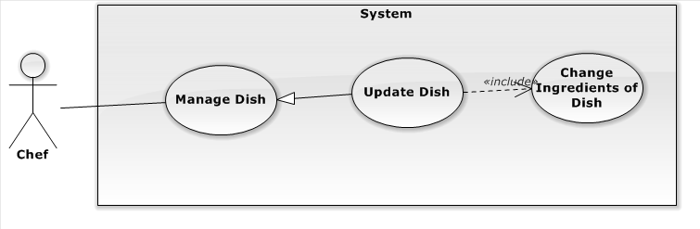
Figure 1-2: Update Dish Use Case
USE CASE SPECIFICATION
Use-case No. | UC001 | Use-case Version | 2.0
Use-case Name | Update Dish
Author | Lê Quang Khương Duy
Date |  | Priority | High
Actor:
Chef
Summary:
Chef modifies existed Dish information.
Goal:
The purpose of Update Dish use case is allowed Chef to request for modifying existed Dish in the system.
Triggers:
Chef wants to modify Dish for EWC service.
Chef clicks on any Dish in “Quản Lý Món Ăn” page.
Preconditions:
User must be logged-in as Chef-role.
Post Conditions:
Success:
- Chef modifies existed Dish successful.
Failure:
- The Chef is presented with an error message on screen.
Main Success Scenario:
Actor Actions | System Response
- Chef clicks on a Dish in “Quản Lý Món Ăn” page.  - Chef modifies the information for the Dish and click “Tiếp tục” button or choose “Chọn nguyên liệu” tab.  - Chef drags and drops Ingredient to the right container then clicks on “Thêm Mới” button.[Alternative 1] [Alternative 2] | - “Sửa Thông Tin Món Ăn” panel shows up on the center of the screen with information of the selected Dish, includes:  - “Thông tin món ăn” tab:  “Tên”[Name: Textbox, max length: 100, require]  “Danh Mục”[Dish Category: Drop down list, includes all Dish Category]  “Giá”[Price: Textbox, require]  “Mô tả” [Description: text area, string]  “Cách nấu” [Cooking Guide: text area, string]  “Tag” [Tag: Textbox with multiple select, send request for searching existed Tag]  “Hình ảnh” [Image: image picker, include a file input and a file-preview label]  “Tiếp tục”[Button]  - “Chọn nguyên liệu” tab:  Ingredient container at the left contains available Ingredients include search input [Keyword, Textbox, max length: 100] and Ingredient Category filter [Ingredient Category, Drop down list, includes all Ingredient Category].  Selected Ingredient container at the right contains Ingredients that Chef chose.  “Trở lại”[Button]  “Chỉnh sửa”[Button]  - Switch to “Chọn nguyên liệu” tab.  [Exception 1] [Exception 2] [Exception 3]  [Exception 4]  - Shows message “Thao tác thành công!” to Chef.

Alternative Scenario:
Actor Actions | System Response
[Alternative 1]  - Chef clicks on “Trở lại” button or choose “Thông tin món ăn” tab.  [Alternative 2]  - Chef types in Keyword textbox. | - Switch back to “Thông tin món ăn” tab.  - Show Ingredient container with suitable filter conditions.

Exceptions:
Actor Actions | System Response
[Exception 1]  - “Tên” field is empty.  [Exception 2]  - “Tên” field content is existed.  [Exception 3]  - “Giá” field content is not a integer.  [Exception 4]  - Selected Ingredient container is empty.  [Exception 5]  - System fails to execute. | - Switch back to “Thông tin món ăn” tab and “Tên” field border turn red with placeholder is “Tên món ăn không được TRỐNG!”.  - Switch back to “Thông tin món ăn” tab and shows error “Tên món ăn không được TRỐNG!” next to “Tên” field.  - Switch back to “Thông tin món ăn” tab and “Giá” field border turn red with placeholder is “Số dương!”.  - Message “Kéo thả nguyên liệu vào khung bên đây” fade in, fade out 3 times.  - Show error message “Lỗi xảy ra. Xin thử lại sau!” .

Relationships:
Manage Dish, Show Dish
Business Rules:
- N/A

3.2.2.5.4. Delete Dish:

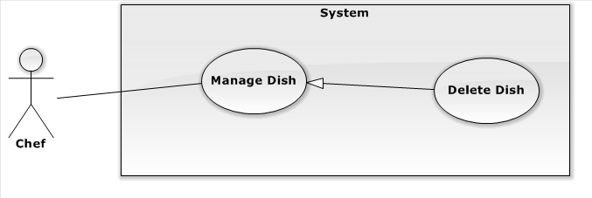
Figure 1-2: Delete Dish Use Case
USE CASE SPECIFICATION
Use-case No. | UC001 | Use-case Version | 2.0
Use-case Name | Delete Dish
Author | Lê Quang Khương Duy
Date |  | Priority | High
Actor:
Chef
Summary:
Chef deletes existed Dish information.
Goal:
The purpose of Delete Dish use case is allowed Chef to request for deleting existed Dish in the system.
Triggers:
Chef wants to delete Dish for EWC service.
Chef clicks on “Xóa” button in “Sửa thông tin Món Ăn” panel of a Dish.
Preconditions:
User must be logged-in as Chef-role.
Post Conditions:
Success:
- Chef deletes existed Dish successful.
Failure:
- The Chef is presented with an error message on screen.
Main Success Scenario:
Actor Actions | System Response
- Chef clicks on “Xóa” button in “Sửa thông tin Món Ăn” panel of a Dish.  - Chef clicks “OK” button.  [Alternative 1] | - Confirm message show up with warning “Bạn có thực sự muốn xóa Món Ăn này?”  “OK”[Button]  “Cancel”[Button]  - Show message “Thao tác thành công!”.[Exception 1]

Alternative Scenario:
Actor Actions | System Response
[Alternative 1]  - Chef clicks on “Cancel” button. | - Dismiss confirm message.

Exceptions:
Actor Actions | System Response
[Exception 1]  - System fails to execute. | - Show error message “Lỗi xảy ra. Xin thử lại sau!”.

Relationships:
Manage Dish, Show Dish, Update Dish.
Business Rules:
- N/A

3.2.2.5.4 Show Dish Category
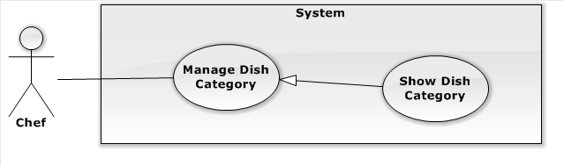
Figure 1-2: Show Dish Category Use Case
USE CASE SPECIFICATION
Use-case No. | UC001 | Use-case Version | 2.0
Use-case Name | Show Dish Category
Author | Lê Quang Khương Duy
Date |  | Priority | High
Actor:
Chef
Summary:
Chef views all Dish Category in EWC service.
Goal:
The purpose of Show Dish Category use case is allowed Chef to request for viewing all Dish Category in the system.
Triggers:
Chef wants to view Dish Category in EWC service.
Chef clicks on “Danh mục Món Ăn” menu in Dish page.
Preconditions:
User must be logged-in as Chef-role.
Post Conditions:
Success:
- Dish Category are shown in table of “Quản Lý Danh Mục Món Ăn” screen match with search conditions.
Failure:
- The Chef is guided to Error page
Main Success Scenario:
Actor Actions | System Response
- Chef clicks on “Danh mục Món Ăn” menu in dish page.  - Chef choose filter options or type keyword for search. | - Redirect to “Quản Lý Món Ăn” page contains list of Dish Category includes:  [Records per page, Drop down list includes 5, 10, 15, All, default is 5]  “Search”[Search Dish Category, Textbox]  Paging control[Paging: list of Action Link, default is set at page 1].  [Exception 1]  - Show list of Dish Category match with search conditions.

Alternative Scenario:
Actor Actions | System Response
N/A | N/A

Exceptions:
Actor Actions | System Response
Exception 1  - System fails to load data. | - Show Error page.

Relationships:
- Manage Dish Category
Business Rules:
- N/A

3.2.2.5.6 Create Dish Category:

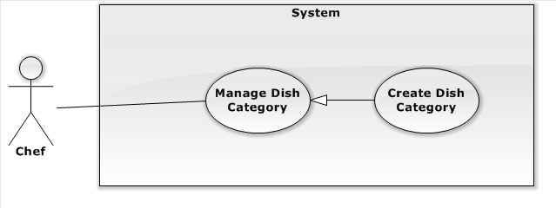
Figure 1-2: Create Dish Category Use Case
USE CASE SPECIFICATION
Use-case No. | UC001 | Use-case Version | 2.0
Use-case Name | Create Dish Category
Author | Lê Quang Khương Duy
Date |  | Priority | High
Actor:
Chef
Summary:
Chef create new Dish Category for EWC service.
Goal:
The purpose of Create Dish Category use case is allowed Chef to request for creating new Dish Category for the system.
Triggers:
Chef wants to create new Dish Category in EWC service.
Chef clicks on “Danh mục Món Ăn” menu on menu bar.
Chef clicks on “Tạo Mới” button.
Preconditions:
User must be logged-in as Chef-role.
Post Conditions:
Success:
- Chef creates new Dish Category successful.
Failure:
- The Chef is presented an error message on screen.
Main Success Scenario:
Actor Actions | System Response
- Chef clicks on “Tạo Mới” button.  - Chef fills Dish Category and clicks on “Lưu” button. [Alternative 1] | - A new empty row is created in the top of Dish Category table includes:  “Tên”[Name: Textbox, max length:100, require]  “Mô tả”[Description: text area, string]  “Hình ảnh” [Image: image picker, include a file input and a file-preview label]  “Hủy”[Button]  “Lưu”[Button]  - Show message “Lưu thành công!”  [Exception 1] [Exception 2] [Exception 3]

Alternative Scenario:
Actor Actions | System Response
Alternative 1  - Chef clicks “Hủy” button. | - Cancel editting on new row and delete it.

Exceptions:
Actor Actions | System Re
Exception 1ponse  - System fails to execute.  Exception 2  - “Tên” field is empty  Exception 3  - “Tên” field is existed in EWC system. | - Show message “Lưu thất bại. Xin thử lại sau”.  - “Tên” field border turn to red and its placeholder is set to “Xin nhập tên”.  - An error message appears next to “Tên” field with content “Tên này đã tồn tại”.

Relationships:
- Manage Dish Category, Show Dish Category
Business Rules:
- N/A

3.2.2.5.7 Update Dish Category:

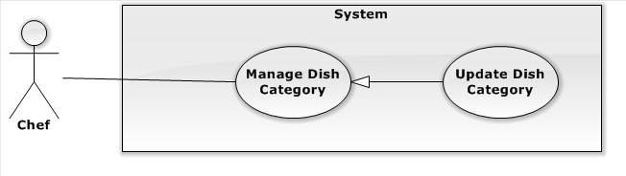
Figure 1-2: Update Dish Category Use Case
USE CASE SPECIFICATION
Use-case No. | UC001 | Use-case Version | 2.0
Use-case Name | Update Dish Category
Author | Lê Quang Khương Duy
Date |  | Priority | High
Actor:
Chef
Summary:
Chef modifies existed Dish Category for EWC service.
Goal:
The purpose of Update Dish Category use case is allowed Chef to request for modifying existed Dish Category for the system.
Triggers:
Chef wants to modifies existed Dish Category in EWC service.
Chef clicks on “Danh mục Món Ăn” menu on menu bar.
Chef clicks on “Sửa” button in any Dish Category row of the table.
Preconditions:
User must be logged-in as Chef-role.
Post Conditions:
Success:
- Chef modifies existed Dish Category successful.
Failure:
- The Chef is presented an error message on screen.
Main Success Scenario:
Actor Actions | S
- Chef clicks on “Sửa” button.stem Response  - Chef modifies Dish Category and clicks on “Lưu” button. [Alternative 1] | - The row of Dish Category turn to editting includes:  “Tên”[Name: Textbox, max length:100, require]  “Mô tả”[Description: text area, string]  “Hình ảnh” [Image: image picker, include a file input and a file-preview label]  “Hủy”[Button]  “Lưu”[Button]  - Show message “Lưu thành công!”  [Exception 1] [Exception 2] [Exception 3]

Alternative Scenario:
Actor Actions | System Response
Alternative 1  - Chef clicks “Hủy” button. | - Cancel editting on new row and restore its information as the earlier.

Exceptions:
Actor Actions | System Response
Exception 1  - System fails to execute.  Exception 2  - “Tên” field is empty  Exception 3  - “Tên” field is existed in EWC system. | - Show message “Lưu thất bại. Xin thử lại sau”.  - “Tên” field border turn to red and its placeholder is set to “Xin nhập tên”.  - An error message appears next to “Tên” field with content “Tên này đã tồn tại”.

Relationships:
- Manage Dish Category, Show Dish Category
Business Rules:
- N/A

3.2.2.5.8: Delete Dish Category

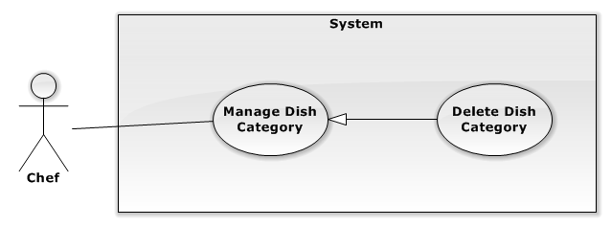
Figure 1-2: Update Dish Category Use Case
USE CASE SPECIFICATION
Use-case No. | UC001 | Use-case Version | 2.0
Use-case Name | Delete Dish Category
Author | Lê Quang Khương Duy
Date |  | Priority | High
Actor:
Chef
Summary:
Chef deletes existed Dish Category for EWC service.
Goal:
The purpose of Update Dish Category use case is allowed Chef to request for deleting existed Dish Category for the system.
Triggers:
Chef wants to deletes existed Dish Category in EWC service.
Chef clicks on “Danh mục Món Ăn” menu on menu bar.
Chef clicks on “Xóa” button in any Dish Category row of the table.
Preconditions:
User must be logged-in as Chef-role.
Post Conditions:
Success:
- Chef deletes existed Dish Category successful.
Failure:
- The Chef is presented an error message on screen.
Main Success Scenario:
Actor Actions | System Response
- Chef clicks on “Xóa” button.  - Chef clicks on “OK” button. [Alternative 1] | - Confirm message show up with warning “Bạn có thực sự muốn xóa Danh Mục này? Tất cả những Món Ăn trong Danh Mục cũng bị xóa!”  “OK”[Button]  “Cancel”[Button]  - Show message “Lưu thành công!”  [Exception 1] [Exception 2] [Exception 3]

Alternative Scenario:
Acto | Actions
Alternative 1ystem Response  - Chef clicks “Hủy” button. | - Dismiss confirm message.

Exceptions:
Actor Actions | System Response
Exception 1  - System fails to execute. | - Show message “Lưu thất bại. Xin thử lại sau”.

Relationships:
- Manage Dish Category, Show Dish Category
Business Rules:
- N/A

Manage Produce Session
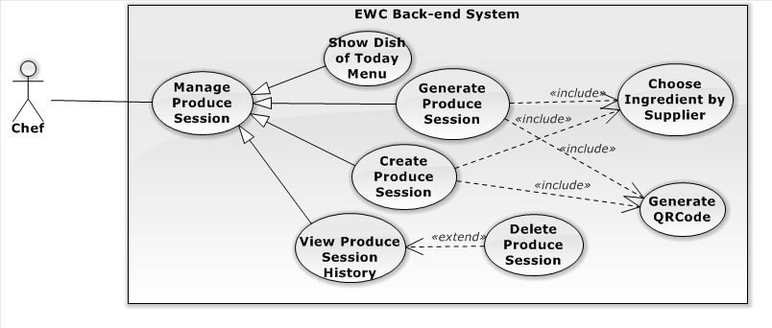
Figure 3-10 Manage produce session usecase diagram

Show dish of today menu
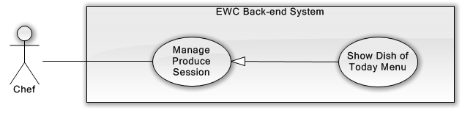
Figure 3-11 Show dish of today menu use case diagram
USE CASE SPECIFICATION
Use-case No. | UC007 | Use-case Version | 2.0
Use-case Name | Show Dish of Today Menu
Author | Lê Quang Khương Duy
Date | 22/01/2014 | Priority | High
Actor:
Chef
Summary:
Chef views all Dish of Today Menu in EWC service.
Goal:
The purpose of Show Dish of Today Menu use case is allowed Chef to request for viewing all Dish of Today Menu in the system.
Triggers:
Chef wants to view Dish of Today Menu in EWC service.
Chef clicks on “Phiên Chế Biến” menu on menu bar.
Preconditions:
User must be logged-in as Chef-role.
Post Conditions:
Success:
- Dish of Today Menu are shown in table of “Quản Lý Phiên Chế Biến” screen match with search conditions.
Failure:
- The Chef is guided to Error page.
Main Success Scenario:
Actor Actions | System Response
- Chef clicks on “Phiên Chế Biến” menu on menu bar.  - Chef chooses filter options or type keyword for search. | - Redirect to “Quản Lý Phiên Chế Biến” page contains list Dish of Today Menu includes:  Rows as “Món Ăn”, “Hình Ảnh”, “Số lượng đã được nấu”, “Số lượng đã đặt hàng” and “Chế Biến”[Button]  [Records per page, Drop down list includes 5, 10, 15, All, default is 5]  “Search”[Search Dish Category, Textbox]  Paging control [Paging: list of Action Link, default is set at page 1].  [Exception 1][Exception 2]  - Show list of Dish match with search conditions.

Alternative Scenario:
Actor Actions | System Response
N/A | N/A

Exceptions:
Actor Actions | System Response
[Exception 1]  - System fails to load data.  [Exception 2]  - Today Menu is not repaired or no Dish in the Menu. | - Show Error page.  - Show message “Rất tiếc! Menu của ngày hôm nay chưa được chuẩn bị. Xin chuẩn bị và quay lại sau!”.

Relationships:
- Manage Produce Session
Business Rules:
- In order to create Produce Session, today Menu must have been repaired.

Generate produce session
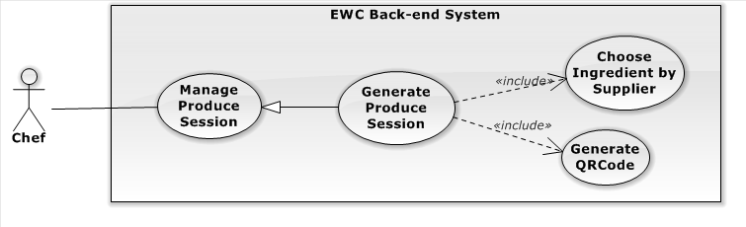
Figure 3-12 Generate produce session use case diagram
USE CASE SPECIFICATION
Use-case No. | UC008 | Use-case Version | 2.0
Use-case Name | Generate Produce Session
Author | Lê Quang Khương Duy
Date | 23/01/2014 | Priority | High
Actor:
Chef
Summary:
System generates Produce Session base on customer order for today Menu. Chef can modify the generated list of Produce Session
Goal:
The purpose of Generate Produce Session use case is allowed Chef to request for generates Produce Session base on customer order for today Menu.
Triggers:
Chef wants to generate Produce Session base on customer order for today Menu.
Chef clicks on “Phiên Chế Biến” menu on menu bar.
Chef clicks on “Chế biến theo đơn hàng” button.
Preconditions:
User must be logged-in as Chef-role.
Post Conditions:
Success:
- Produce Sessions are generated successfully.
Failure:
- The Chef is presented with an error message on screen.
Main Success Scenario:
Actor Actions | System Response
- Chef clicks on “Chế biến theo đơn hàng” button.  - Chef checks dishes need to be cooked, fill the quantity and clicks on “Chế biến” button.  [Alternative 1] | - “Chế biến theo đơn hàng” panel shows up with a table contains all dish need to be cooked on the center of the screen, includes:  “Món Ăn”, “Danh Mục”, “Hình ảnh”,  “Số lượng nấu theo đơn hàng” [“Quantity: Textbox, max length: 3, require]  “Nguồn gốc” [Button]  “Chế biến”[Button]  - Selected Produce Session generated successfully and refresh page to show new changes [Exception 1]

Alternative Scenario:
Actor Actions | System Response
[Alternative 1]  - Chef clicks on “Nguồn gốc” button. | - “Nguồn gốc nguyên liệu” panel show up includes ingredient name and their suppliers for each ingredient.

Exceptions:
Actor Actions | System Response
[Exception 1]  - System fails to execute. | - Show error message “Lỗi xảy ra! Xin thử lại sau”.

Relationships:
- Manage Produce Session, Show Dish of Today Menu
Business Rules:
None

Create produce session
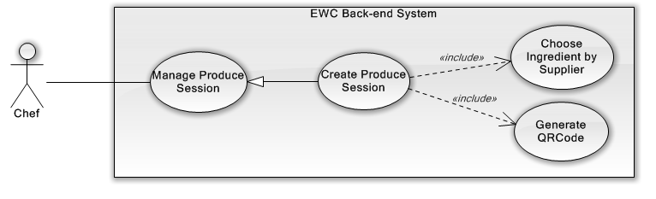
Figure 3-13 Create produce session use case diagram
USE CASE SPECIFICATION
Use-case No. | UC009 | Use-case Version | 2.0
Use-case Name | Create Produce Session
Author | Lê Quang Khương Duy
Date | 24/01/2014 | Priority | High
Actor:
Chef
Summary:
Chef create new Produce Session
Goal:
The purpose of Create Produce Session use case is allowed Chef to request for creating new Produce Session in the system.
Triggers:
Chef wants to create Produce Session for EWC service.
Chef clicks on “Phiên Chế Biến” menu on menu bar to access “Quản Lý Phiên Chế Biến” page and then click “Chế biến”  button.
Preconditions:
User must be logged-in as Chef-role.
Post Conditions:
Success:
- Chef creates new Produce Session successful.
Failure:
- The Chef is presented with an error message on screen.
Main Success Scenario:
Actor Actions | System Response
- Chef clicks “Chế biến” button.  - Chef fills in “Số lượng” and selects Supplier for each Ingredient and then click “Chế biến”. [Alternative 1]  - Chef click on x button of “Phát sinh QRCode” panel or click outside. [Alternative 2] | - “Tạo Phiên Chế Biến” panel shows up on the center of the screen, includes:  “Món Ăn”[Name: Textbox, max length: 100, readonly]  “Hình ảnh” [Image]  “Số lượng” [“Quantity: Textbox, max length: 3, require]  “Nguyên liệu” [list of multi-select input for each Ingredient of the Dish]  “Khôi phục mặc định” [Button]  “Chế biến”[Button]  - “Phát sinh QRCode” panel show up includes: Dish Name, Quantity and “Nhấn Vào Đây” button in case that chef want to re-download QRCode image.[Exception 1]  - “Phát sinh QRCode” panel dismiss and page is refreshed. [Exception 2]

Alternative Scenario:
Actor Actions | System Response
[Alternative 1]  - Chef clicks on “Khôi phục mặc định” button.  [Alternative 2]  - Chef clicks on “Bỏ Qua” button. | - “Số lượng” is set to 5 and default Supplier for each Ingredient are used.  - Force dismiss “Phát sinh QRCode” panel whatever QRCode image is downloaded or not.

Exceptions:
Actor Actions | System Response
[Exception 1]  - System fails to execute.  [Exception 2]  - QRCode image is not downloaded. | - Show error message “Lỗi xảy ra. Xin thử lại sau!”  - “Phát sinh QRCode” panel re-open then show message “Mã QRCode cho sản phẩm vẫn chưa được tải xuống!” and a download link “Nhấn vào đây”

Relationships:
Manage Produce Session, Show Dish of Today Menu
Business Rules:
None

View produce session history
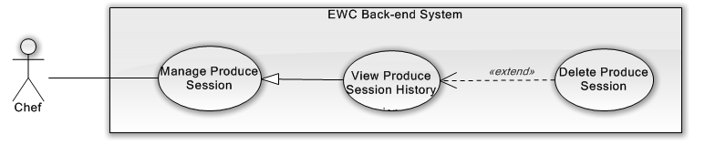
Figure 3-14 View produce session history use case diagram
USE CASE SPECIFICATION
Use-case No. | UC010 | Use-case Version | 2.0
Use-case Name | View Produce Session History
Author | Lê Quang Khương Duy
Date | 25/01/2014 | Priority | High
Actor:
Chef
Summary:
Chef view Produce Session History
Goal:
The purpose of View Produce Session History use case is allowed Chef to request for viewing Produce Session History in the system.
Triggers:
Chef wants to view Produce Session History in EWC service.
Chef clicks on “Phiên Chế Biến” menu on menu bar to access “Quản Lý Phiên Chế Biến” page and then click “Lịch sử Phiên Chế Biến” button.
Preconditions:
User must be logged-in as Chef-role.
Post Conditions:
Success:
- Produce Session are shown in table of “Lịch sử Phiên Chế Biến” screen match with search conditions.
Failure:
- The Chef is presented with an error message on screen.
Main Success Scenario:
Actor Actions | System Response
- Chef clicks on “Lịch sử Phiên Chế Biến” button.  - Chef chooses filter options or type keyword for search.  [Alternative 1] [Alternative 2] | - Show up “Lịch sử Phiên Chế Biến” page contains list of Produce Session includes:  [Records per page, Drop down list includes 10, 25, 50, 100, All, default is 10]  “Chọn ngày”[Date, Date Picker, default is set today]  “Search”[Search Produce Session, Textbox]  Paging control [Paging: list of Action Link, default is set at page 1].  [Exception 1]  - Show list of Dish Category match with search conditions. [Exception 2]

Alternative Scenario:
Actor Actions | System Response
[Alternative 1]  - Chef clicks on “Tải xuống” button in the specific row of Produce Session.  [Alternative 2]  - Chef clicks on “Xóa”  button in the specific row of Produce Session.  - Chef clicks “OK” button.  [Alternative 3]  [Alternative 3]  - Chef clicks on “Cancel” button. | - Re-download QRCode for the Dish of Produce Session.  - Show confirm message “Bạn có thực sự muốn xóa Phiến Chế Biến này không?”.  “OK”[Button]  “Cancel”[Button]  - Remove row contains deleted Produce Session.[Exception 2][Exception 3]  - Dismiss confirm message.

Exceptions:
Actor Actions | System Response
[Exception 1]  - System fails to load data.  [Exception 2]  - Dish of this Produce Session has been delivered.  [Exception 3]  - System fails to execute. | - Show error message “Lỗi hệ thống! Xin thử lại sau.”  - Show message “Do sản phẩm này đã được giao hàng nên không thể xóa!”  - Show error message “Lỗi hệ thống! Xin thử lại sau.”

Relationships:
- Manage Produce Session
Business Rules:
- Cannot delete delivered Produce Session.

Manage menu
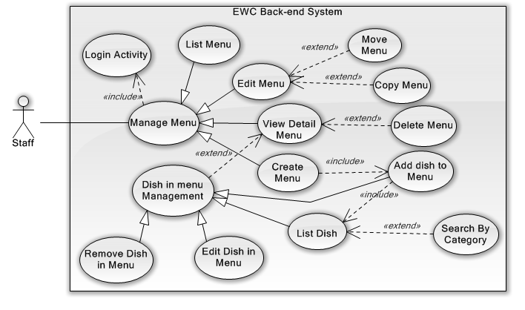
Figure 3-15 Manage menu use case diagram

3.2.2.6.1 Menu Management
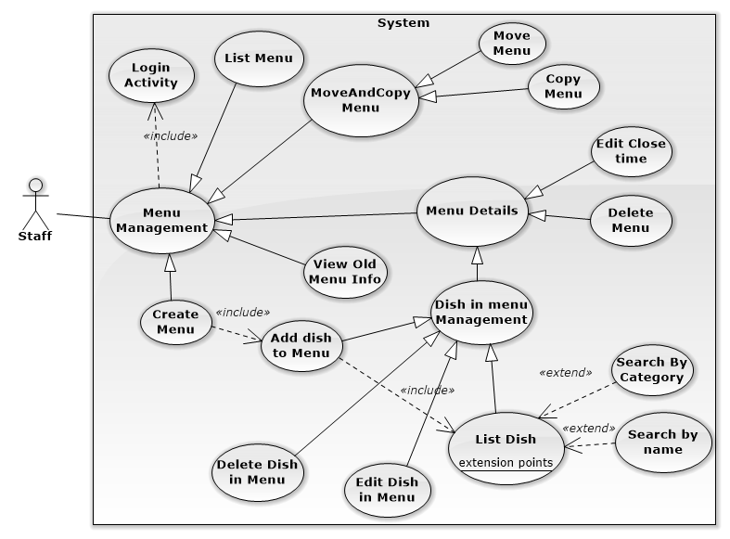

3.2.2.6.2 List Menu:
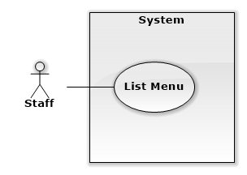

USE CASE SPECIFICATION
Use-case No. | UC001 | Use-case Version | 2.0
Use-case Name | List Menu
Author | Trương Quang Bảo
Date | 17/03/2014 | Priority | High
Actor:
Staff
Summary:
List all menu in calendar
Goal:
The purpose of Show Dish Category use case is allowed staff view all menu by time
Triggers:
Trigger when Staff click “Menu” in menu bar.
Preconditions:
User must log in with role “Staff”.
Post Conditions:
Success:
- Show Calendar page
- Show all Menu in Calendar with right time.
Failure:
- Page not load, system show Error page.
- Menu not show in calendar screen or show with wrong time.
Main Success Scenario:
Actor Actions | System Response
1. Staff click “Menu” in left sidebar.  [Exception 1] | 2. Redirect to “Calendar” page. Show all menu by time in calendar
Alternative Scenario:
Actor Actions | System Response
- N/A | - N/A
Exceptions:
Actor Actions | System Response
[Exception 1]  1. System fails to load data. | 2. Show Error page.
Relationships:
- Create Menu Use case.
- Menu Details Use case.
- Suggest Menu Use case.
Business Rules:
- One day not contain more than one menu.

3.2.2.6.3 Create Menu:
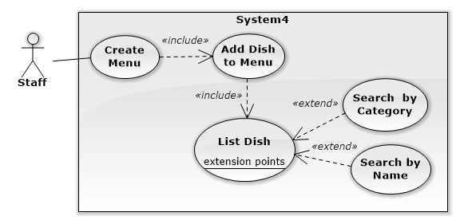

USE CASE SPECIFICATION
Use-case No. | UC002 | Use-case Version | 2.0
Use-case Name | Create Menu
Author | Trương Quang Bảo
Date | 17/03/2014 | Priority | High
Actor:
Staff
Summary:
Staff create new menu and add dish to this menu.
Goal:
The purpose of Create Dish Category use case is allowed staff insert a new menu and add dish to menu for convenience way.
Triggers:
Trigger when Staff click date field in calendar, add dish and click “lưu” button.
Preconditions:
User must log in with role “Staff”.
Post Conditions:
Success:
- New Menu insert into database and display on calendar page with right date.
Failure:
- System show error message on screen.
Main Success Scenario:
Actor Actions | System Response
1. Staff click date field at present time or future in calendar.  3. Staff drag dish from field “Món Ăn” and drop it in field “Menu”.  [Alternative 1] [Alternative 2] [Alternative 3] [Alternative 4]  5. Click “lưu” button  [Alternative 5][Alternative 6][Exception 3] | 2. Show Create menu popup model include:  - Left field name “Món Ăn” show all dish with name and imgae.  - [DishCategory: dropdown list, string ].  - [SearchbyName:textbox, string].  - Right field name “Menu” for drop dish into.  - “Xuất hiện đến: [ClosedTimeSession: datetime picker,datetime].  4. Dish disappear in “Món Ăn” and appear in “Menu”  6. Redirect calendar page. New menu appear in calendar with right date apply.

Alternative Scenario:
Actor Actions | System Response
[Alternative 1]  1. Staff click button “đóng”  [Alternative 2]  1. Staff chose category in category filter dropdown list.  [Alternative3]  1. Staff types in “Tìm kiếm theo tên” textbox.  [Alternative 4]  1. Staff input close time session in “Xuất hiện đến” textbox and click button “lưu”.  [Alternative 5]  1. Staff click button “sửa” beside price of dish in menu field.  3. Staff input price(x) and click button “Ok”.  [Exceptions 1]  [Alternative 6]  1. Staff click button “sửa” beside quota of dish in menu field.  3. Staff input quota(x) and click button “Ok”.  [Exceptions 2] | 2.Close popup, do nothing.  2.Show dish with suitable category filter conditions.  2. Show dish with suitable name filter conditions.  2.Create new menu with close time session inputed.  2.Show prompt edit price [Textbox, positive integer].  4.System show success message “Giá của món ăn đã được đổi thành x”.  2.Show prompt edit quota [Textbox, positive integer].  4.System show success message “Số lượng của món ăn đã được đổi thành x”

Exceptions:
Actor Actions | System Response
[Exceptions 1]  1.Input price isn’t a number or less than 1.  [Exceptions 2]  1.Input quota isn’t a number or less than 1.  [Exceptions 3]  1.No dish in field “Menu” | 2.System show error message:” Dữ liệu không đúng, giá của món ăn phải là số nguyên dương!”.  2.System show error message:” Dữ liệu không đúng, số lượng của món ăn phải lớn hơn 1!”.  2.System show message:”Cần có ít nhất một món ăn trong menu”
Relationships:
- List Dish Use case.
- Create Menu Use case.
- Menu Management Use case.
Business Rules:
- Can’t create Menu at past time.
- Menu has least one dish.

3.2.2.6.4 Menu Details:

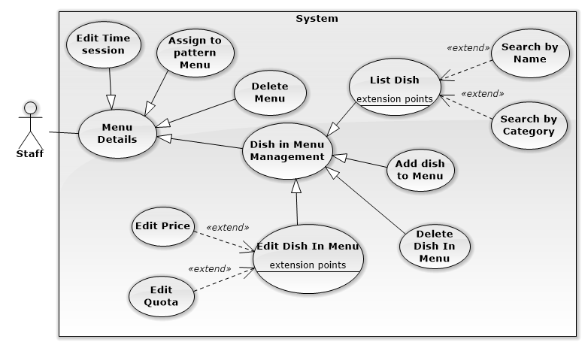

3.2.2.6.4.1 Edit Time Close Session:
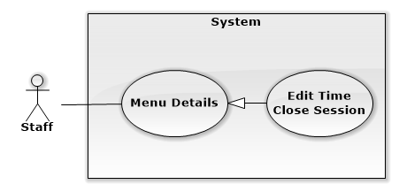
USE CASE SPECIFICATION
Use-case No. | UC003 | Use-case Version | 2.0
Use-case Name | Edit Time Close Session
Author | Trương Quang Bảo
Date | 18/03/2014 | Priority | Low
Actor:
Staff
Summary:
Helps staff edit time close session of Menu.
Goal:
The purpose of Edit time close session Use case is allowed staff can edit success time start of menu.
Triggers:
Trigger when Staff click menu item at present or future day in calendar and edit close time session.
Preconditions:
- User must log in with role “Staff
- Has least one menu at present or future day in calendar.
Post Conditions:
Success:
- Time close session change in Menu Details popup.
Failure:
- System show error message in screen.
Main Success Scenario:
Actor Actions | System Response
1.Staff click menu at present or future date in calendar.  3. Input time close session info. | 2. Show Menu Details popup model include:  - Left field name “Món Ăn” show all dish not in menu.  - Dish item not in Menu include: dish name[text], dish image[image].  - Right field name “Menu” show all dish in menu.  - Dish item in Menu include: dish name[text], dish image[image], dish price[label], dish quota[label].  - “Xuất hiện đến: [ClosedTimeSession: datetime picker,datetime].  - [DishCategory: dropdown list, string ].  4. Time close session change in screen. Show success message.
Alternative Scenario:
Actor Actions | System Response
N/A | N/A
Exceptions:
Actor Actions | System Response
N/A | N/A
Relationships:
- N/A
Business Rules:
- N/A

3.2.2.6.4.2 Assign to pattern Menu:
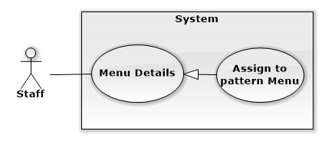
USE CASE SPECIFICATION
Use-case No. | UC004 | Use-case Version | 2.0
Use-case Name | Assign to pattern Menu
Author | Trương Quang Bảo
Date | 18/03/2014 | Priority | Low
Actor:
Staff
Summary:
Helps staff assign Menu to pattern Menu.
Goal:
The purpose of this Use case is allowed staff can assign Menu to pattern Menu. After that, staff can use pattern Menu for copy Menu function.
Triggers:
Trigger when Staff click menu item in calendar and click button “Xuất”.
Preconditions:
- User must log in with role “Staff
- Has least one menu in calendar.
Post Conditions:
Success:
- Menu selected appear in “Menu Mẫu”.
Failure:
- System show error message in screen.
Main Success Scenario:
Actor Actions | System Response
1. Staff click menu in calendar.  2. Click button “Mẫu”. | 2. Show Menu Details popup model or Old Menu info popup model.  4. Reload page. This Menu appear in field “Menu Mẫu.
Alternative Scenario:
Actor Actions | System Response
N/A | N/A
Exceptions:
Actor Actions | System Response
N/A | N/A
Relationships:
- N/A
Business Rules:
- N/A

3.2.2.6.4.3 Delete Menu:
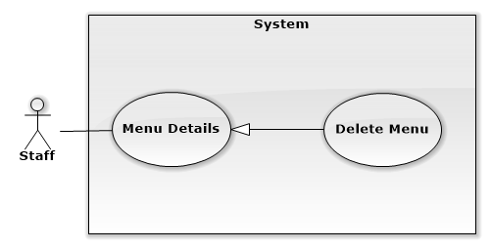
USE CASE SPECIFICATION
Use-case No. | UC005 | Use-case Version | 2.0
Use-case Name | Delete Menu
Author | Trương Quang Bảo
Date | 18/03/2014 | Priority | Normal
Actor:
Staff
Summary:
Helps staff delete Menu.
Goal:
The purpose of Delete Menu Use case is allowed staff can delete Menu and all dish in this Menu.
Triggers:
Trigger when Staff click menu item at present or future day in calendar and click button “Xóa”
Preconditions:
- User must log in with role “Staff
- Has least one menu in calendar.
Post Conditions:
Success:
- Reload page, Menu disappear in page calendar.
Failure:
- System show error message in screen.
Main Success Scenario:
Actor Actions | System Response
1. menu item at present or future day in calendar.  3. Click button “Xóa”. | 2. Show Menu Details popup model include:  - Left field name “Món Ăn” show all dish not in menu.  - Dish item not in Menu include: dish name[text], dish image[image].  - Right field name “Menu” show all dish in menu.  - Dish item in Menu include: dish name[text], dish image[image], dish price[label], dish quota[label].  - “Xuất hiện đến: [ClosedTimeSession: datetime picker,datetime].  - [DishCategory: dropdown list, string ].  4. Reload page. Menu disappear in calendar page.
Alternative Scenario:
Actor Actions | System Response
N/A | N/A
Exceptions:
Actor Actions | System Response
N/A | N/A
Relationships:
- Dish in Menu Management
Business Rules:
- Can’t delete Menu in past.

3.2.2.6.4.4 Dish in Menu Management:
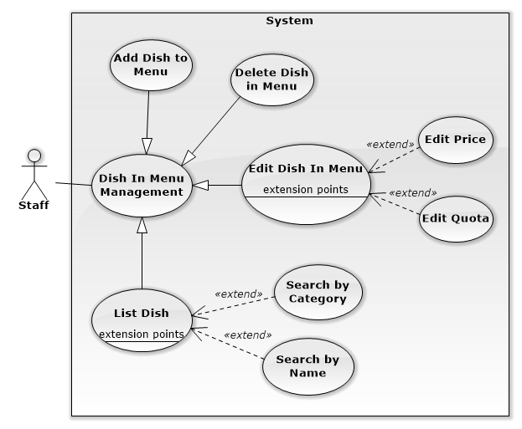

3.2.2.6.4.4 List Dish:
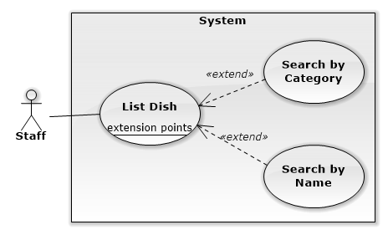
USE CASE SPECIFICATION
Use-case No. | UC006 | Use-case Version | 2.0
Use-case Name | List Dish
Author | Trương Quang Bảo
Date | 18/03/2014 | Priority | High
Actor:
Staff
Summary:
Help staff see list dish in menu and not in menu.
Goal:
The purpose of List Dish Use case is show for staff all dish not in Menu and all dish in Menu.
Triggers:
Trigger when Staff click menu item in calendar.
Preconditions:
- User must log in with role “Staff
- Has least one menu in calendar.
Post Conditions:
Success:
- Show Menu Details popup.
Failure:
- System show error message in screen.
Main Success Scenario:
Actor Actions | System Response
1. Staff click menu in calendar.  [Alternative 1][Alternative 2] | 2. Show Menu Details popup model include:  - Left field name “Món Ăn” show all dish not in menu.  - Dish item not in Menu include: dish name[text], dish image[image].  - Right field name “Menu” show all dish in menu.  - Dish item in Menu include: dish name[text], dish image[image], dish price[label], dish quota[label].  - “Xuất hiện đến: [ClosedTimeSession: datetime picker,datetime].  - [DishCategory: dropdown list, string ].
Alternative Scenario:
Actor Actions | System Response
[Alternative 1]  1. Staff chose category in category filter dropdown list.  [Alternative 2]  1. Staff types in “Tìm kiếm theo tên” textbox. | 2. Show dish not in Menu with suitable category filter conditions.  2. Show dish not in Menu with suitable name filter conditions.
Exceptions:
Actor Actions | System Response
N/A | N/A
Relationships:
- Dish in Menu Management
Business Rules:
- One Menu has least one Dish.

3.2.2.6.4.5 Add Dish To Menu:
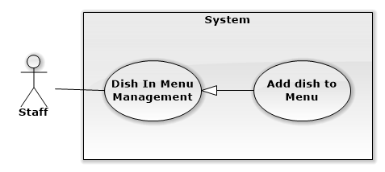
USE CASE SPECIFICATION
Use-case No. | UC007 | Use-case Version | 2.0
Use-case Name | Add Dish to Menu
Author | Trương Quang Bảo
Date | 18/03/2014 | Priority | High
Actor:
Staff
Summary:
Help staff add new Dish to selected Menu.
Goal:
The purpose of Add Dish to Menu Use case is allowed Staff can add Dish to selected Menu.
Triggers:
Trigger when Staff click menu item at present or future day in calendar. Drag and drop dish into Menu field.
Preconditions:
- User must log in with role “Staff
- Has least one dish in data.
Post Conditions:
Success:
- Dish disappear in “Món Ăn” and appear in Menu field
Failure:
- System show error message in screen.
Main Success Scenario:
Actor Actions | System Response
1. menu item at present or future day in calendar  3. Staff drag dish from “Món Ăn” and drop it into “Menu”. | 2. Show Menu Details popup model include:  - Left field name “Món Ăn” show all dish not in menu.  - Dish item not in Menu include: dish name[text], dish image[image].  - Right field name “Menu” show all dish in menu.  - Dish item in Menu include: dish name[text], dish image[image], dish price[label], dish quota[label].  - “Xuất hiện đến: [ClosedTimeSession: datetime picker,datetime].  - [DishCategory: dropdown list, string ].  4. Dish disappear in “Món Ăn” and appear in “Menu”.
Alternative Scenario:
Actor Actions | System Response
N/A | N/A
Exceptions:
Actor Actions | System Response
N/A | N/A
Relationships:
- Dish in Menu Management
Business Rules:
- N/A

3.2.2.6.4.7 Delete Dish in Menu:
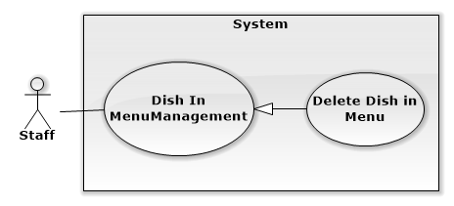

USE CASE SPECIFICATION
Use-case No. | UC008 | Use-case Version | 2.0
Use-case Name | Delete Dish in Menu
Author | Trương Quang Bảo
Date | 18/03/2014 | Priority | Normal
Actor:
Staff
Summary:
Help staff delete Dish in Menu.
Goal:
The purpose of Delete Dish in Menu Use case is allowed Staff can remove dish in Menu.
Triggers:
Trigger when Staff click menu item at present or future day in calendar. Click red button X beside dish item.
Preconditions:
- User must log in with role “Staff.
- Has least two Dish in Menu.
Post Conditions:
Success:
- Dish disappear in “Menu” and appear in “Món Ăn” field
Failure:
- System show error message in screen.
Main Success Scenario:
Actor Actions | System Response
1. Staff click menu item at present or future day in calendar  3. Click button beside dish item “Món Ăn”.  [Exception 1] | 2. Show Menu Details popup model include:  - Left field name “Món Ăn” show all dish not in menu.  - Dish item not in Menu include: dish name[text], dish image[image].  - Right field name “Menu” show all dish in menu.  - Dish item in Menu include: dish name[text], dish image[image], dish price[label], dish quota[label].  - “Xuất hiện đến: [ClosedTimeSession: datetime picker,datetime].  - [DishCategory: dropdown list, string ].  4. Dish disappear in “Menu” and appear in “Món Ăn”.
Alternative Scenario:
Actor Actions | System Response
N/A | N/A
Exceptions:
Actor Actions | System Response
[Exception 1]  1. Selected dish to delete is a last dish in Menu. | 2. Show error message “Cần có ít nhất một món ăn trong Menu”.
Relationships:
- Dish in Menu Management.
Business Rules:
- One menu has least one dish.

3.2.2.6.4.8 Edit Dish in Menu:

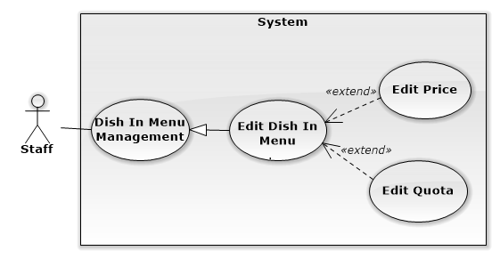

USE CASE SPECIFICATION
Use-case No. | UC009 | Use-case Version | 2.0
Use-case Name | Edit Dish in Menu
Author | Trương Quang Bảo
Date | 18/03/2014 | Priority | Normal
Actor:
Staff
Summary:
Help staff Edit Dish in Menu.
Goal:
The purpose of Edit Dish in Menu Use case is allowed Staff can edit price and quota of dish in Menu.
Triggers:
Trigger when Staff click menu item at present or future day in calendar. Click red button X beside dish item.
Preconditions:
- User must log in with role “Staff
- Has least one dish in Menu.
Post Conditions:
Success:
- Save new Price and Quota of Dish in database. Display new Price and Quota in screen.
Failure:
- System show error message in screen.
Main Success Scenario:
Actor Actions | System Response
1. Staff click menu item at present or future day in calendar  3. Click button in Dish item “Món Ăn”.  [Alternative 1], [Alternative 2] | 2. Show Menu Details popup model include:  - Left field name “Món Ăn” show all dish not in menu.  - Dish item not in Menu include: dish name[text], dish image[image].  - Right field name “Menu” show all dish in menu.  - Dish item in Menu include: dish name[text], dish image[image], dish price[label], dish quota[label].  - “Xuất hiện đến: [ClosedTimeSession: datetime picker,datetime].  - [DishCategory: dropdown list, string ].  4. Dish disappear in “Menu” and appear in “Món Ăn”.
Alternative Scenario:
Actor Actions | System Response
[Alternative 1]  1. Staff click button beside price of dish in menu field.  3. Staff input price(x) and click button “Ok”.  [Exceptions 1]  [Alternative 2]  1. Staff click button beside quota of dish in menu field.  3. Staff input quota(x) and click button“Ok”.  [Exceptions 2]. | 2. Show prompt edit price [Textbox, positive integer].  4. System show success message “Giá của món ăn đã được đổi thành x”.  2. Show prompt edit quota [Textbox, positive integer].  4. System show success message “Số lượng của món ăn đã được đổi thành x”.
Exceptions:
Actor Actions | System Response
[Exceptions 1]  1. Input price isn’t a number or less than 1.  [Exceptions 2]  1. Input quota isn’t a number or less than 1. | 2. System show error message:” Dữ liệu không đúng, giá của món ăn phải là số nguyên dương!”  2. System show error message:”Dữ liệu không đúng, số lượng của món ăn phải lớn hơn 1!”
Relationships:
- Dish in Menu Management.
Business Rules:
- Price can’t less than 1.
- Quota can’t less than 1.

3.2.2.6.5 MoveAndCopy Menu:
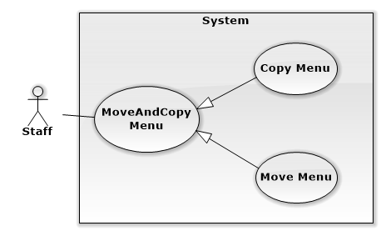
USE CASE SPECIFICATION
Use-case No. | UC010 | Use-case Version | 2.0
Use-case Name | MoveAndCopyMenu
Author | Trương Quang Bảo
Date | 18/03/2014 | Priority | Normal
Actor:
Staff
Summary:
Helps staff move and copy menu in another day.
Goal:
The purpose of Edit Dish in Menu Use case is allowed Staff can move or copy from selected Menu to another Menu.
Triggers:
Trigger when Staff drag and drop selected menu to another day, click button “sao chép” or “di chuyển”.
Preconditions:
- User must log in with role “Staff.
- Has least one menu in calendar.
Post Conditions:
Success:
- Menu appear in calendar in field day was changed.
Failure:
- System show error message on screen.
Main Success Scenario:
Actor Actions | System Response
1. Staff drag and drop selected menu to another day.  [Alternative 1] [Alternative 2] [Alternative 3]  [Exception1] | 2. Show popup Edit Menu.

Alternative Scenario:
Actor Actions | System Response
[Alternative 1]  1. Staff click button “Di Chuyển”  [Alternative 2]  1. Staff click button “Sao Chép”  [Alternative 3]  1. Staff click button “Đóng” | 2. Reload page. Show Menu in calendar in day menu was drop. Menu name change.  Change time selected menu in database.  2. Calendar show old and new copy menu in appropriate day. New copy menu insert in database.  2. Popup close, menu revert to original day.

Exceptions:
Actor Actions | System Response
[exception 1]  1. The day menu selected to drop in is existing another menu. | 2. System show error message: ”Menu ngày … đã có sẵn”
Relationships:
- Menu management.
Business Rules:
- One day have only one menu.
- Can’t move or drop menu to past day.

3.2.2.6.6. Suggest Menu:

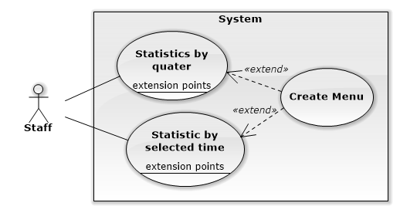
USE CASE SPECIFICATION
Use-case No. | UC011 | Use-case Version | 2.0
Use-case Name | Suggest Menu
Author | Trương Quang Bảo
Date | 19/03/2014 | Priority | Normal
Actor:
Staff
Summary:
Statistics information about number success order by quarter or selected time. Create new menu by suggest dish.
Goal:
Show statistics information about number success order by quarter or selected time in chart. Staff success create new menu by suggest dish if they want.
Triggers:
Trigger when Staff click button “Thống Kê” in calendar page.
Preconditions:
- User must log in with role “Staff
- Has least one success order.
Post Conditions:
Success:
- Statistics info show right. Create success new menu.
Failure:
- System show error message on screen.
Main Success Scenario:
Actor Actions | System Response
1.Staff click “Thống kê” button.  [alternative 1][ Alternative 2]  3. Staff select dish, input datetime, click “Tạo Menu”.  [Exception 1] [Exception 2] | 2. Show popup “suggest menu” include:  - “Thời gian: [quarter:dropdown list,integer]  - “Hiển thị”:[dropdown list, integer]  - “Năm”:[year:dropdownlist, integer]  - “Từ ngày:[textbox: datetime]  - “Đến ngày:[textbox:datetime]  - “Chọn ngày:[textbox:datetime]  - Tạo Menu: [button:button]

Alternative Scenario:
Actor Actions | System Response
[alternative 1]  1. Staff input “Thời gian”, “Hiển thị”,”Năm”. Click button “Kết quả”.  [alternative 2]  1. Staff input “Từ ngày”, “Đến ngày”,”Hiển thị”. Click button “Kết quả” | 2. Show info number order of dish in chart.  Show suggest dish with checkbox for staff create new menu if they want.  2. Show info number order of dish in chart.  Show suggest dish with checkbox for staff create new menu if they want.

Exceptions:
Actor Actions | System Response
[Exception 1]  1. Staff not select any dish and click “Tạo Menu”  [Exception 2]  1. Input date is existing | 2. System show error message:”Cần có ít nhất một món ăn trong menu”.  2. System show error message:”Menu cho ngày này đã có, bạn có thể chỉnh sửa”.
Relationships:
- Menu management
Business Rules:
- One day have only one menu.

Manage supplier
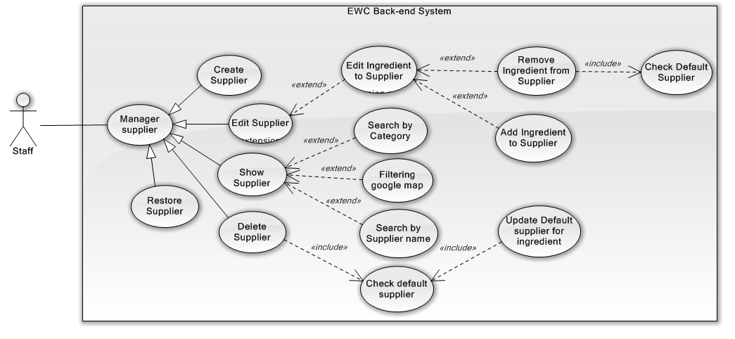
Figure 3-18 Manage supplier usecase diagram

Create supplier
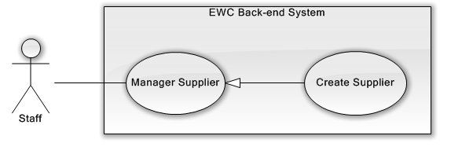
Figure 3-19 Create supplier use case diagram
USE CASE SPECIFICATION
Use-case No. | UC013 | Use-case Version | 2.0
Use-case Name | Create new supplier
Author | Phạm Văn Duy
Date | 20/01/2014 | Priority | Medium
Actor:
Staff
Summary:
Staff creates new supplier
Goal:
The purpose of Create new supplier use case is allowed Staff to request for creating new supplier in the system.
Triggers:
Staff wants to create new supplier
Staff clicks on “Nhà cung cấp” menu on menu bar and then click on the “Thêm mới” button.
Preconditions:
User must logged-in as Staff-role.
Post Conditions:
Success:
- The Staff is presented with an success message on screen.
Failure:
- The Staff is presented with an error message on screen.
Main Success Scenario:
Actor Actions | System Response
- Staff clicks on the “Nhà cung cấp” menu on menu bar.  - Staff clicks on “Thêm mới” button.  - Staff fills supplier information form and clicks on “Thêm” button. | - Redirect to “Nhà cung cấp” page  - The pop up “Thêm nhà cung cấp” is displayed on screen. Supplier information form includes:  - “Tên” [Name of supplier, Textbox, max length: 100, require]  - “Số điện thoại”[Phone number, Textbox, regular expression: (^[0-9]{10,11}$), require]  - “Danh mục”[Category of Supplier, Dropdown list include all category available]  - “Địa chỉ”[Address, Textbox, The under is google map for staff choose address]  - “Thêm” button.  [Exception 1] [Exception 2]  [Exception 3] [Exception 4]  [Exception 5] [Exception 6]  [Exception 7] [Exception 8]  [Exception 9]  - The pop up is closed and message is displayed “Thêm nhà cung cấp thành công”.

Alternative Scenario:
N/A
Exceptions:
Actor Actions | System Response
[Exception 1]  - Supplier’s “Tên” is missing.  [Exception 2]  - The length of Supplier’s “Tên” is out of range.  [Exception 3]  - Supplier’s Name is exist.  [Exception 3]  - Supplier’s “Số điện thoại” is missing.  [Exception 4]  - Supplier’s “Số điện thoại” is not in correct format.  [Exception 5]  - Supplier’s “Địa chỉ” is missing.  [Exception 6]  - Supplier’s “Địa chỉ” is not correct.  [Exception 7]  - System cannot create supplier.  [Exception 8]  - System fails to load Supplier. | - Shows error “Không được để trống!” on textbox.  - Shows error “Tên quá dài (hơn 100 ký tự) on screen.  - Shows error “Tênnày đã tồn tại!.”) on screen.  - Shows error “Không được để trống!” on textbox.  - Shows error “Số điện thoại không đúng” to customer.  - Shows error “Không được để trống!” on textbox.  - Shows error “Địa chỉ không đúng!” on textbox.  - Shows error “Xảy ra lỗi, xin hay thử lại!” on screen.  - Show message “Hệ thống không thể kết nối với cơ sở dữ liệu.”

Relationships:
N/A
Business Rules:
N/A

Edit supplier
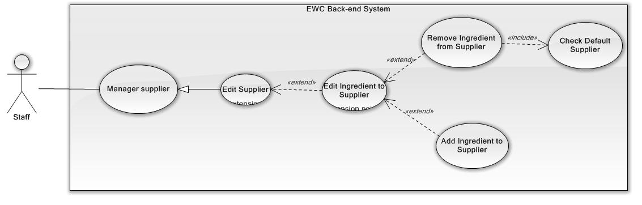
Figure 3-20 Edit supplier use case diagram
USE CASE SPECIFICATION
Use-case No. | UC014 | Use-case Version | 2.0
Use-case Name | Edit supplier
Author | Phạm Văn Duy
Date | 22/01/2014 | Priority | Medium
Actor:
Staff
Summary:
Staff edit supplier
Goal:
The purpose of Edit supplier use case is allowed Staff to request for edit supplier in the system.
Triggers:
Staff wants to create new supplier
Staff clicks on “Nhà cung cấp” menu on menu bar and then click on the button in the table of supplier. Modify information and then click “Lưu” button.
Preconditions:
User must logged-in as Staff-role.
Post Conditions:
Success:
- The Staff is presented with success message on screen.
Failure:
- The Staff is presented with an error message on screen.
Main Success Scenario:
Actor Actions | System Response
- Staff clicks on the “Nhà cung cấp” menu on menu bar.  - Staff clicks on the button in the table of supplier.  - Staff fills supplier information form.  - Staff clicks on “Lưu” button.  - Staff clicks on the button in the table of supplier.  - Staff clicks on the tag “Chọn nguyên liệu”.  - Staff drag ingredient from the left container to the right container.  [Alternative 1][ Alternative 2]  15. Staff presses the “Lưu” button.  [Alternative 3] | - Redirect to “Nhà cung cấp” page  - The pop up “Thông tin nhà cung cấp” is displayed on screen.  - Supplier information form includes:  - “Tên” [Name of supplier, Textbox, max length: 100, require]  - “Số điện thoại”[Phone number, Textbox, regular expression: (^[0-9]{10,11}$), require]  - “Danh mục”[Category of Supplier, Dropdown list include all category available]  - “Địa chỉ”[Address, Textbox, The under is google map for staff choose address]  - “Lưu” button.  [Exception 1] [Exception 2]  [Exception 3] [Exception 4]  [Exception 5] [Exception 6]  [Exception 7] [Exception 8]  [Exception 9]  - Message display “Cập nhập nhà cung cấp thành công!”  - The pop up “Thông tin nhà cung cấp” is displayed on screen.  - The view ingredients is displayed include:  - The view contains all ingredients in the left.  - The Selected Ingredient Container in the right.  14. The ingredient in the left container s removed to the right container.  [Exception 8] [Exception 9]  [Exception 10]  - The pop up is closed and the message is displayed “Cập nhập thành công!”

Alternative Scenario:
Actor Actions | System Response
[Alternative 1]  - Staff presses the “X” button of ingredient in the right container andthen click “OK” button.  - Staff presses the “Lưu” button.  [Alternative 2]  - Press the “X” button of ingredient in the right container, then press “Cancle” button in the message box. | - The pop up is displayed included:  - List of all other supplier.  - “Lưu” button.  - The message box is closed.

Exceptions:
Actor Actions | System Response
[Exception 1]  - Supplier’s “Tên” is missing.  [Exception 2]  - Supplier’s “Name” is existing.  [Exception 3]  - The length of Supplier’s “Name” is out of range.  [Exception 4]  - Supplier’s “Số điện thoại” is missing.  [Exception 5]  - Supplier’s “Số điện thoại” is not in correct format.  [Exception 6]  - Supplier’s “Địa chỉ” is missing.  [Exception 7]  - Supplier’s “Địa chỉ” is not correct.  [Exception 8]  - System cannot Edit supplier.  [Exception 9]  - System cannot load supplier.  [Exception 10]  - The right containter is empty. | - Shows error “Không được để trống!” on textbox.  - Shows error “Tên này đã tồn tại” under textbox.  - Shows error “Tên quá dài (hơn 250 ký tự) on screen.  - Shows error “Không được để trống!” on textbox.  - Shows error “Số điện thoại không đúng” to customer.  - Shows error “Không được để trống!” on textbox.  - Shows error “Địa chỉ không đúng!” on textbox.  - Shows error “Xảy ra lỗi, xin hay thử lại.!” on screen.  - Show message “Hệ thống không thể kết nối với cơ sở dữ liệu.”  - Show error “Cần có ít nhất 1 nguyên liệu” on screen.

Relationships:
- Edit ingredient of supplier
Business Rules:
N/A

Delete supplier
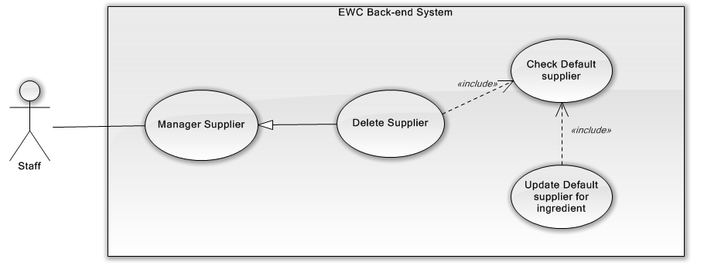
Figure 3-21 Delete supplier use case diagram
USE CASE SPECIFICATION
Use-case No. | UC015 | Use-case Version | 2.0
Use-case Name | Delete Supplier
Author | Phạm Văn Duy
Date | 23/01/2014 | Priority | Low
Actor:
Staff
Summary:
Staff Delete supplier
Goal:
The purpose of delete supplier use case is allowed Staff to request for delete supplier in the system.
Triggers:
Staff wants to delete supplier
Staff clicks on “Nhà cung cấp” menu on menu bar and then click on the button of supplier.
Preconditions:
User must logged-in as Staff-role.
Post Conditions:
Success:
- The Staff is presented with a success message on screen.
Failure:
- The Staff is presented with an error message on screen.
Main Success Scenario:
Actor Actions | System Response
- Staff clicks on the “Nhà cung cấp” menu on menu bar.  - Staff clicks con the button of supplier.  - Staff click “OK” button  [Alternative 1]  - Staff choose supplier and click “Lưu” button. | - Redirect to “Nhà cung cấp” page  - System check selected supplier is being default of any ingredient?  - If result is false: System will set IsActive to false.  - If result is true: System will display confirm box.  [Exception 1]  - The pop up window is displayed included:  - List of ingredient which have default supplier is selected supplier.  - List of the other supplier  - “Lưu” button.  [Exception 1] [Exception 2]  [Exception 3]  - The message is displayed:”Xóa thành công”.

Alternative Scenario:
Actor Actions | System Response
[Alternative 1]  - Staff click “Cancel” button. | - The pop up window is closed.

Exceptions:
Actor Actions | System Response
[Exception 1]  - System cannot load.  [Exception 2]  - System cannot delete supplier.  [Exception 3]  - System cannot save supplier default of ingredient. | - Show message “Hệ thống không thể kết nối với cơ sở dữ liệu.”  - Show message “Xảy ra lỗi, xin hãy thử lại!”  - Show message “Xảy ra lỗi, xin hãy thử lại!”

Relationships:
N/A
Business Rules:
N/A

Show supplier
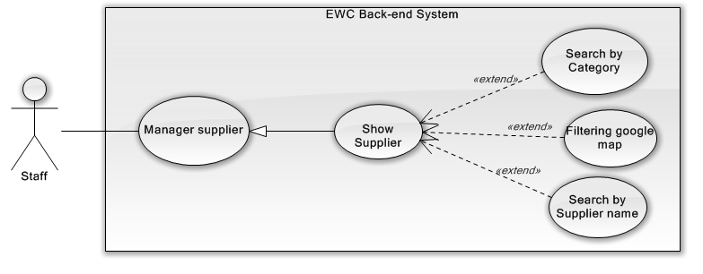
Figure 3-22 Show supplier use case diagram

USE CASE SPECIFICATION
Use-case No. | UC016 | Use-case Version | 2.0
Use-case Name | Show Supplier
Author | Phạm Văn Duy
Date | 24/01/2014 | Priority | Medium
Actor:
Staff
Summary:
Staff show supplier
Goal:
The purpose of show supplier use case is allowed Staff to request for viewing all suppliers on screen in the system.
Triggers:
Staff wants to show supplier
Staff clicks on “Nhà cung cấp” menu on menu bar.
Preconditions:
User must logged-in as Staff-role.
Post Conditions:
Success:
- Suppliers are shown in table of “Quản lý nhà cung cấp” screen match with search conditions.
Failure:
- The Staff is presented with an error message on screen.
Main Success Scenario:
Actor Actions | System Response
- Staff clicks on the “Nhà cung cấp” menu on menu bar.  - Staff chooses filter options or type keyword for search.  - Staff filters on Google map by tick into category checkbox. | - Redirect to “Nhà cung cấp” page include:  - Search section: : includes  “Tìm kiếm” [Keyword: TextBox, default is Empty]  - Two filter for Supplier Category [Supplier Category Filter: Drop-down list, default is “Tất cả danh mục”] and sorting [Sort Filter: Drop-down list, default is “Tên: A đến Z”].  - Paging control [Paging: list of Action Link, default is set at page 1].  - Supplier Panel section: includes result suppliers for search conditions.  - Google map[Default marker is empty]  - Table contains all categories to filter on Google map.  - Supplier panel display list of suitable suppliers for filter options.  [Exception 1]  - Google shows all markers of suppliers which have category are selected category.  [Exception 2]

Alternative Scenario:
Actor Actions | System Response
N/A | N/A

Exceptions:
Actor Actions | System Response
[Exception 1]  1. System cannot load.  [Exception 2]  1. System cannot load marker of supplier. | 2. Show message “Hệ thống không thể kết nối với cơ sở dữ liệu.”  2. Show message “Không tìm thấy đia điểm!”

Relationships:
N/A
Business Rules:
N/A

3.2.2.8.5 Restore Supplier
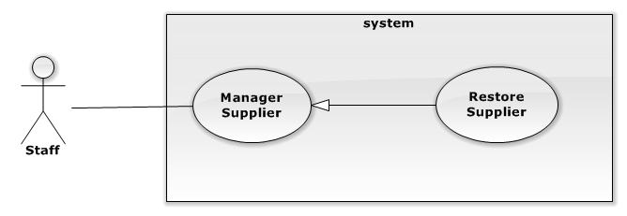
USE CASE SPECIFICATION
Use-case No. |  | Use-case Version
Use-case Name | Restore Supplier
Author | Phạm văn Duy
Date |  | Priority
Actor:
Staff
Summary:
Staff restore supplier
Goal:
The purpose of restore supplier use case is allowed Staff to request for restore supplier after delete in the system.
Triggers:
Staff wants to restore supplier
Staff clicks on “Nhà cung cấp” menu on menu bar and then click on the button of supplier.
Preconditions:
User must logged-in as Staff-role.
Post Conditions:
Success:
- The Staff is presented with an success message on screen.
Failure:
- The Staff is presented with an error message on screen.
Main Success Scenario:
Actor Actions | System Response
1. Staff click on the “Nhà cung cấp” menu on menu bar.  3. Staff clicks on the button of supplier.  5. Staff click “OK” button  [Alternative 1] | 2. Redirect to “Nhà cung cấp” page  4. The confirm box is show.  6. System will set IsActive to False and reload page.  [Exception 1] [Exception 2]

Alternative Scenario:
Actor Actions | System Response
[Alternative 1]  1. Staff click “Cancel” button. | 2. The pop up windowis closed.

Exceptions:
Actor Actions | System Response
[Exception 1]  1 . System cannot load.  [Exception 2]  1. System cannot restore supplier. | 2. Show message “Hệ thống không thể kết nối với cơ sở dữ liệu.”  2. Show message “Xảy ra lỗi, xin hãy thử lại!.”

Relationships:
N/A
Business Rules:
N/A

3.2.2.8.6 Create Ingredient
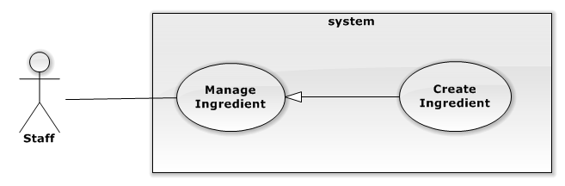
USE CASE SPECIFICATION
Use-case No. |  | Use-case Version
Use-case Name | Create new ingredient
Author | Phạm văn Duy
Date |  | Priority
Actor:
Staff
Summary:
Staff creates new ingredient.
Goal:
The purpose of Create new ingredient use case is allowed Staff to request for creating new ingredient in the system.
Triggers:
Staff wants to create new ingredient
Staff clicks on “Nguyên liệu” menu on menu bar and then click on the “Thêm mới” button.
Preconditions:
User must logged-in as Staff-role.
Post Conditions:
Success:
- The Staff is presented with an success message on screen.
Failure:
- The Staff is presented with an error message on screen.
Main Success Scenario:
Actor Actions | System Response
- Staff click on the “Nguyên liệu” menu on menu bar.  3. Staff clicks on the “Thêm mới” button.  7. Staff fills ingredient information form and clicks on “Thêm” button. | - Redirect to “Nhà cung cấp” page  4. The pop up “Thêm nguyên liệu” is displayed on screen. Ingredient information form includes:  - “Tên” [Name of ingredient , Textbox, max length: 100, require]  - “Danh mục”[Category of Supplier, Dropdown list include all category available]  - “Nhà cung cấp mặc định” [Supplier default of ingredient]  - “Hình ảnh”[Image of ingredient, File (Default file is empty)].  - “Truy nguyên” [Tracibility of ingredient(Default if false)]  - “Thêm” button.  [Exception 1] [Exception 2]  [Exception 3] [Exception 4]  [Exception 5]  8. The pop up is closed and the message is displayed “Thêm nguyên liệu thành công”.

Alternative Scenario:
Actor Actions | System Response
N/A | N/A

Exceptions:
Actor Actions | System Response
[Exception 1]  1. Ingredient’s “Tên” is missing.  [Exception 2]  1. The length of Supplier’s “Tên” is out of range.  [Exception 3]  1. Ingredient’s “Tên” is exist.  [Exception 4]  1. System cannot create ingredient.  [Exception 5]  1. System fails to load ingredient. | 2. Shows error “Không được để trống!” on textbox.  - Shows error “Tên quá dài (hơn 100 ký tự) under “Tên” texbox.  2. Shows error “Tên này đã tồn tại!” under “Tên” textbox.  2. Shows error ”Xảy ra lỗi, xin hãy thử lại.!” on screen.  2. Show message “Hệ thống không thể kết nối với cơ sở dữ liệu.”

Relationships:
N/A
Business Rules:
- Max character of “Tên” is 100 .
- Name is not identical.

3.2.2.8.7 Edit Ingredient
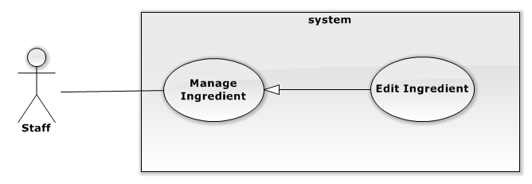
USE CASE SPECIFICATION
Use-case No. |  | Use-case Version
Use-case Name | Edit ingredient
Author | Phạm văn Duy
Date |  | Priority
Actor:
Staff
Summary:
Staff edits new ingredient.
Goal:
The purpose of edits ingredient use case is allowed Staff to request for editing ingredient in the system.
Triggers:
Staff wants to edits ingredient
Staff clicks on “Nguyên liệu” menu on menu bar and then click on the ingredient.
Preconditions:
User must logged-in as Staff-role.
Post Conditions:
Success:
- The Staff is presented with an success message on screen.
Failure:
- The Staff is presented with an error message on screen.
Main Success Scenario:
Actor Actions | System Response
- Staff click on the “Nguyên liệu” menu on menu bar.  3. Staff clicks on the Ingredient.  7. Staff edit ingredient information form and clicks on “Thêm” button. | - Redirect to “Nhà cung cấp” page  4. The pop up “Thông tin nguyên liệu” is displayed on screen. Ingredient information form includes:  - “Tên” [Name of ingredient , Textbox, max length: 100, require]  - “Danh mục”[Category of Supplier, Dropdown list include all category available]  - “Nhà cung cấp mặc định” [Supplier default of ingredient]  - “Hình ảnh”[Image of ingredient, File (Default file is empty)].  - “Truy nguyên” [Tracibility of ingredient(Default if false)]  - “Thêm” button.  - “Xóa” button.  [Exception 1] [Exception 2]  [Exception 3] [Exception 4]  [Exception 5]  8. The pop up is closed and the message is displayed “Thêm nguyên liệu thành công”.

Alternative Scenario:
Actor Actions | System Response
N/A | N/A

Exceptions:
Actor Actions | System Response
[Exception 1]  1. Ingredient’s “Tên” is missing.  [Exception 2]  1. The length of Supplier’s “Tên” is out of range.  [Exception 3]  1. Ingredient’s “Tên” is exist.  [Exception 4]  1. System cannot create ingredient.  [Exception 5]  1. System fails to load ingredient. | 2. Shows error “Không được để trống!” on textbox.  - Shows error “Tên quá dài (hơn 100 ký tự) under “Tên” texbox.  2. Shows error “Tên này đã tồn tại!” under “Tên” textbox.  2. Shows error ”Xảy ra lỗi, xin hãy thử lại.!” on screen.  2. Show message “Hệ thống không thể kết nối với cơ sở dữ liệu.”

Relationships:
N/A
Business Rules:
N/A

3.2.2.8.8 Delete ingredient
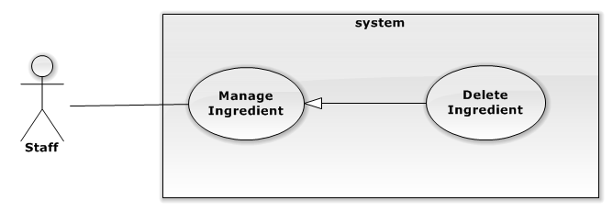
USE CASE SPECIFICATION
Use-case No. |  | Use-case Version
Use-case Name | Delete ingredient
Author | Phạm văn Duy
Date |  | Priority
Actor:
Staff
Summary:
Staff delete supplier
Goal:
The purpose of delete supplier use case is allowed Staff to request for delete ingredient in the system.
Triggers:
Staff wants to delete supplier
Staff clicks on “Nhà cung cấp” menu on menu bar and then click on the ingredient and click “Xóa” button on pop up window.
Preconditions:
User must logged-in as Staff-role.
Post Conditions:
Success:
- The Staff is presented with an success message on screen.
Failure:
- The Staff is presented with an error message on screen.
Main Success Scenario:
Actor Actions | System Response
1. Staff click on the “Nguyên liệu” menu on menu bar.  3. Staff clicks on the Ingredient.  5. Staff click “Xóa” button  - Staff click ”OK” button  [Alternative 1] | 2. Redirect to “Quản lí nguyên liệu” page  4. The pop up “Thông tin nguyên liệu” is displayed on screen. Ingredient information form includes:  - “Tên” [Name of ingredient , Textbox, max length: 100, require]  - “Danh mục”[Category of Supplier, Dropdown list include all category available]  - “Nhà cung cấp mặc định” [Supplier default of ingredient]  - “Hình ảnh”[Image of ingredient, File (Default file is empty)].  - “Truy nguyên” [Tracibility of ingredient(Default if false)]  - “Thêm” button.  - “Xóa” button.  6. The confirm box will be displayed.  8. Show message “Xóa thành công!.”  [Exception 1] [Exception 2]

Alternative Scenario:
Actor Actions | System Response
[Alternative 1]  1. Staff click “Cancel” button. | 2. The pop up windowis closed.

Exceptions:
Actor Actions | System Response
[Exception 1]  1 . System cannot load.  [Exception 2]  1. System cannot restore supplier. | 2. Show message “Hệ thống không thể kết nối với cơ sở dữ liệu.”  2. Show message “Xảy ra lỗi, xin hãy thử lại!.”

Relationships:
N/A
Business Rules:
N/A

3.2.2.8.9 Show ingredient
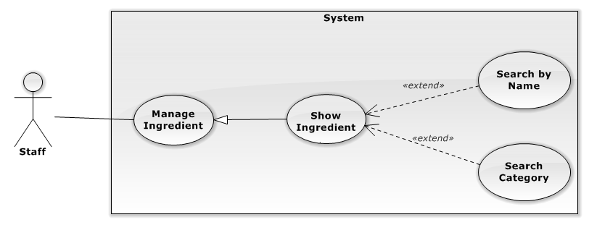
USE CASE SPECIFICATION
Use-case No. |  | Use-case Version
Use-case Name | Show ingredient
Author | Phạm văn Duy
Date |  | Priority
Actor:
Staff
Summary:
Staff show ingredient
Goal:
The purpose of show ingredient use case is allowed Staff to request for viewing all ingredient on screen in the system.
Triggers:
Staff wants to show ingredient
Staff clicks on “Nguyên liệu” menu on menu bar.
Preconditions:
User must logged-in as Staff-role.
Post Conditions:
Success:
- Ingredient are shown in table of “Quản lí nguyên liệu” screen match with search conditions.
Failure:
- The Staff is presented with an error message on screen.
Main Success Scenario:
Actor Actions | System Response
1. Staff click on the “Nguyên liệu” menu on menu bar.  3. Staff choose filter oftions or type keyword for search. | 2. Redirect to “Quản lí nguyên liệu” page include:  - Search section: : includes  “Tìm kiếm”[Keyword: TextBox, default is Empty]  - Two filter for Supplier Category[Supplier Category Filter: Drop-down list, default is “Tất cả danh mục”] and sorting[Sort Filter: Drop-down list, default is “Tên: A đến Z”].  - Paging control[Paging: list of Action Link, default is set at page 1].  - Supplier Panel section: includes result ingredients for search conditions.  4. Ingredient panel display list of suitable ingredients for filter options.  [Exception 1]

Alternative Scenario:
Actor Actions | System Response
N/A | N/A

Exceptions:
Actor Actions | System Response
[Exception 1]  1 . System cannot load. | 2. Show message “Hệ thống không thể kết nối với cơ sở dữ liệu.”

Relationships:
N/A
Business Rules:
N/A

3.2.2.9. Manage User
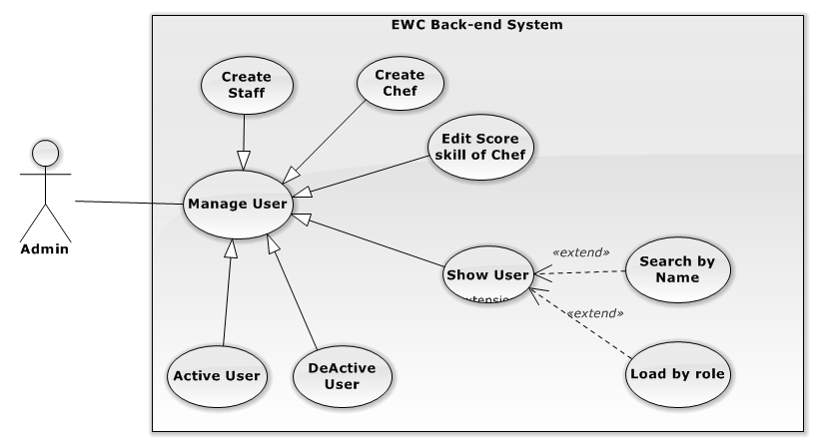
Figure 3-23 Manage user use case diagram

3.2.2.9.2 Create Staff
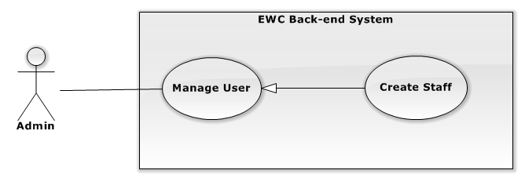
Figure 3-24 Create staff use case diagram
USE CASE SPECIFICATION
Use-case No. | UC017 | Use-case Version | 2.0
Use-case Name | Create new staff
Author | Phạm Văn Duy
Date | 25/01/2014 | Priority | Medium
Actor:
Admin
Summary:
Admin creates new staff.
Goal:
The purpose of Create new staff use case is allowed Admin to request for creating new staff in the system.
Triggers:
Admin wants to create new staff
Admin clicks on “Nhân viên” menu on menu bar and then click on the “Thêm mới” button.
Preconditions:
User must logged-in as Admin-role.
Post Conditions:
Success:
- The Admin is presented with a success message on screen.
Failure:
- The Admin is presented with an error message on screen.
Main Success Scenario:
Actor Actions | System Response
- Admin clicks on the “Nhân viên” menu on menu bar.  - Admin clicks on “Thêm mới” button.  - Admin fills staff information form and clicks on “Thêm” button. | - Redirect to “Quản lí Nhân viên” page  - The pop up “Thêm Tài khoản” is displayed on screen. User information form includes:  - “Tên đăng nhập” [Username of Staff, Textbox, maxlength: 50 require].  - “Mật khẩu” [Password of user, Textbox].  - “Xác nhận Mật khẩu” [Password of user, Textbox].  - “Tên đầy đủ” [Name of user, Textbox, max length: 100, require].  - “Email” [Email of user, Textbox, regular expression: ^ ([a-zA-Z0-9_\.\-])+\@ (([a-zA-Z0-9\-]) +\.) + ([a-zA-Z0-9] {2,4})+$].  - “Số điện thoại” [Phone number: Numeric Textbox, regular expression: ^[0-9]{8,11}$].  - “Ngày sinh” [Birthday, regular expression: ^([0-9]{4})-([0-9]{2})-([0-9]{2})$].  - “Địa chỉ”[Address,Texbox)].  - “Giới tính” [Gender of user (Default is Name)].  - “Thêm” button.  [Exception 1] [Exception 2]  [Exception 3] [Exception 4]  [Exception 5] [Exception 6]  [Exception 7] [Exception 8]  [Exception 9] [Exception 10]  [Exception 11] [Exception 12]  [Exception 13] [Exception 14]  [Exception 15] [Exception 16]  [Exception 17]  - The pop up is closed and message is displayed “Thêm Tài khoản thành công”.

Alternative Scenario:
N/A
Exceptions:
Actor Actions | System Response
[Exception 1]  - User “Tên đăng nhập” is missing.  [Exception 2]  1. The length of User’s “Tên đăng nhập” is out of range.  [Exception 3]  1. User’s “Tên đăng nhập” is exist.  [Exception 4]  1. User “Mật khẩu” is missing.  [Exception 5]  1. User “Xác nhận” is missing.  [Exception 6]  1. “Mật khẩu” don’t match with “Xác nhận mật khẩu”.  [Exception 7]  1. User “Tên đầy đủ” is missing.  [Exception 8]  1. The length of User’s “Tên đầy đủ” is out of range.  [Exception 9]  1. User “Email” is missing.  [Exception 10]  1. User “Email” is not correct format.  [Exception 11]  1. User “Ngày sinh” is missing.  [Exception 12]  1. User “Số điện thoại” is missing.  [Exception 13]  1. User “Số điện thoại” is not correct format  [Exception 14]  1. User “Ngày sinh” is not correct format.  [Exception 15]  1. User “Địa chỉ” is missing.  [Exception 16]  1. System cannot create user.  [Exception 17]  1. System fails to load user. | 2. Shows error “Không được để trống!” on textbox.  2. Shows error “Ký tự quá dài (hơn 100 ký tự) under “Tên” texbox.  2. Shows error “Tên này đã tồn tại!” under “Tên đăng nhập” textbox.  2. Shows error “Không được để trống!” on textbox.  2. Shows error “Không được để trống!” on textbox.  2. Shows error “Mật khẩu không trùng!” under “Xác nhận mật khẩu” textbox.  2. Shows error “Không được để trống!” on textbox.  2. Shows error “Ký tự quá dài (hơn 100 ký tự) under “Tên đầy đủ” texbox.  2. Shows error “Không được để trống!” on textbox.”  2. Shows error “Email không hợp lệ!” on textbox.  2. Shows error “Không được để trống!” on textbox.  2. Shows error “Không được để trống!” on textbox.  2. Shows error “Số điện thoại không hợp lệ!” on textbox.  2. Shows error “Ngày sinh không hợp lệ!” on textbox.  2. Shows error “Không được để trống!” on textbox.  2. Show message “Xảy ra lỗi, Xin hãy thử lại.”  2. Show message “Hệ thống không thể kết nối với cơ sở dữ liệu.”

Relationships:
N/A
Business Rules:
N/A

3.2.2.9.3 Create Chef
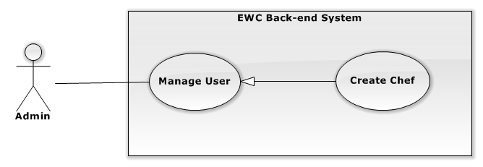
Figure 3-25 Create chef use case diagram
USE CASE SPECIFICATION
Use-case No. | UC018 | Use-case Version | 2.0
Use-case Name | Create new chef
Author | Phạm Văn Duy
Date | 25/01/2014 | Priority | Medium
Actor:
Admin
Summary:
Admin creates new chef.
Goal:
The purpose of Create new chef use case is allowed Admin to request for creating new chef in the system.
Triggers:
Admin wants to create new chef.
Admin clicks on “Đầu bếp” menu on menu bar and then click on the “Thêm mới” button.
Preconditions:
User must logged-in as Admin-role.
Post Conditions:
Success:
- The Admin is presented with an success message on screen.
Failure:
- The Admin is presented with an error message on screen.
Main Success Scenario:
Actor Actions | System Response
- Admin clicks on the “Đầu bếp” menu on menu bar.  - Admin clicks on “Thêm mới” button.  - Admin fills chef information form and clicks on “Thêm” button. | - Redirect to “Quản lí Đầu bếp” page  - The pop up “Thêm Đầu bếp” is displayed on screen. Chef information form includes:  _ “Thông tin” Tab:  - “Tên đăng nhập” [Username of Staff, Textbox, maxlength: 50, require].  - “Mật khẩu” [Password of user, Textbox].  - “Xác nhận Mật khẩu” [Password of user, Textbox].  - “Tên đầy đủ” [Name of user, Textbox, max length: 100, require].  - “Email” [Email of user, Textbox, regular expression: ^ ([a-zA-Z0-9_\.\-])+\@ (([a-zA-Z0-9\-]) +\.) +([a-zA-Z0-9] {2,4})+$].  - “Số điện thoại” [Phone number: Numeric Textbox, regular expression: ^[0-9]{8,11}$].  - “Ngày sinh” [Birthday, regular expression: ^([0-9]{4})-([0-9]{2})-([0-9]{2})$].  - “Địa chỉ”[Address,Texbox)].  - “Giới tính” [Gender of user (Default is Name)].  - “Tiếp tục” button.  _ “Kĩ năng” tab:  - “Kĩ năng”[List of skill, Dropdown list include all skill].  - “Điểm” [Score of skill, slider].  - “Trở lại” button.  - “Thêm” button.  - “Đóng” button.  [Exception 1] [Exception 2]  [Exception 3] [Exception 4]  [Exception 5] [Exception 6]  [Exception 7] [Exception 8]  [Exception 9] [Exception 10]  [Exception 11] [Exception 12]  [Exception 13] [Exception 14]  [Exception 15] [Exception 16]  [Exception 17] [Exception 18]  - The pop up is closed and message is displayed “Thêm Tài khoản thành công”.

Alternative Scenario:
N/A
Exceptions:
Actor Actions | System Response
[Exception 1]  - Chef “Tên đăng nhập” is missing.  [Exception 2]  1. The length of Chef’s “Tên đăng nhập” is out of range.  [Exception 3]  1. Chef’s “Tên đăng nhập” is existing.  [Exception 4]  1. Chef “Mật khẩu” is missing.  [Exception 5]  1. Chef “Xác nhận” is missing.  [Exception 6]  1. “Mật khẩu” don’t match with “Xác nhận mật khẩu”.  [Exception 7]  1. Chef “Tên đầy đủ” is missing.  [Exception 8]  1. The length of Chef’s “Tên đầy đủ” is out of range.  [Exception 9]  1. Chef “Email” is missing.  [Exception 10]  1. Chef “Email” is not correct format.  [Exception 11]  1. Chef “Ngày sinh” is missing.  [Exception 12]  1. Chef “Số điện thoại” is missing.  [Exception 13]  1. Chef “Số điện thoại” is not correct format  [Exception 14]  1. Chef “Ngày sinh” is not correct format.  [Exception 15]  1. Chef “Địa chỉ” is missing.  [Exception 16]  1. Chef skill is missing.  [Exception 17]  1. System cannot create Chef.  [Exception 18]  1. System fails to load Chef. | 2. Shows error “Không được để trống!” on textbox.  2. Shows error “Ký tự quá dài (hơn 100 ký tự) under “Tên” texbox.  2. Shows error “Tên này đã tồn tại!” under “Tên đăng nhập” textbox.  2. Shows error “Không được để trống!” on textbox.  2. Shows error “Không được để trống!” on textbox.  2. Shows error “Mật khẩu không trùng!” under “Xác nhận mật khẩu” textbox.  2. Shows error “Không được để trống!” on textbox.  2. Shows error “Ký tự quá dài (hơn 100 ký tự) under “Tên đầy đủ” texbox.  2. Shows error “Không được để trống!” on textbox.”  2. Shows error “Email không hợp lệ!” on textbox.  2. Shows error “Không được để trống!” on textbox.  2. Shows error “Không được để trống!” on textbox.  2. Shows error “Số điện thoại không hợp lệ!” on textbox.  2. Shows error “Ngày sinh không hợp lệ!” on textbox.  2. Shows error “Không được để trống!” on textbox.  2. Show message “Cần có ít nhất một kĩ năng.”  2. Show message “Xảy ra lỗi, Xin hãy thử lại.”  2. Show message “Hệ thống không thể kết nối với cơ sở dữ liệu.”

Relationships:
N/A
Business Rules:
N/A

3.2.2.9.4 Edit score of skill of Chef
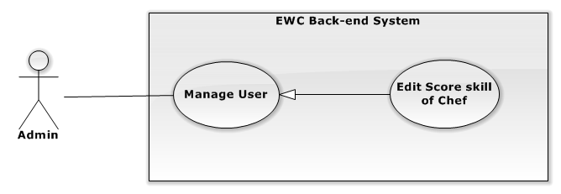
Figure 3-26 edit score skill of chef
USE CASE SPECIFICATION
Use-case No. | UC019 | Use-case Version | 2.0
Use-case Name | Edit score skill of Chef
Author | Phạm Văn Duy
Date | 25/01/2014 | Priority | Low
Actor:
Admin
Summary:
Admin edit supplier
Goal:
The purpose of Edit score of skill of Chef use case is allowed Admin to request for edit score of skill of chef in the system.
Triggers:
Admin wants to edit score of skill of Chef.
Admin clicks on “Đầu bếp” menu on menu bar and then click on the button in the table of chef. Modify information and then click “Lưu” button.
Preconditions:
User must logged-in as Admin -role.
Post Conditions:
Success:
- The Admin is presented with an success message on screen.
Failure:
- The Admin is presented with an error message on screen.
Main Success Scenario:
Actor Actions | System Response
- Admin clicks on the “Đầu bếp” menu on menu bar.  - Admin clicks on the button in the table of chef.  - Admin click on “Kĩ năng” tab.  - Admin change skill of chef and click “Lưu” button. | - Redirect to “Quản lí đầu bếp” page  - The pop up “Thông tin đầu bếp” is displayed on screen.  - “Kĩ năng” tab is displayed include:  - Kĩ năng”[List of skill, Dropdown list include all skill].  - “Điểm” [Score of skill, slider].  - “Trở lại” button.  - “Thêm” button.  - “Đóng” button.  [Exception 1] [Exception 2]  [Exception 3]  - Message display “Cập nhập thành công!”

Alternative Scenario:
Actor Actions | System Response
[Alternative 1]
N/A

Exceptions:
Actor Actions | System Response
[Exception 1]  1. Chef skill is missing.  [Exception 17]  1. System cannot save.  [Exception 18]  1. System fails to load Chef. | - Show message “Cần có ít nhất một kĩ năng.”  2. Show message “Xảy ra lỗi, Xin hãy thử lại.”  2. Show message “Hệ thống không thể kết nối với cơ sở dữ liệu.”

Relationships:
N/A
Business Rules:
N/A

3.2.2.9.5 Delete user
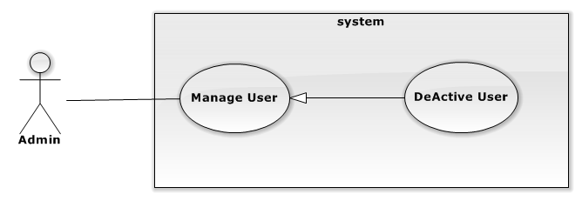
USE CASE SPECIFICATION
Use-case No. |  | Use-case Version
Use-case Name | Deactive user
Author | Phạm văn Duy
Date |  | Priority
Actor:
Staff
Summary:
Staff deactive user
Goal:
The purpose of deactive user use case is allowed Staff to request for deactive user in the system.
Triggers:
Staff wants to deactive user.
Staff clicks on “Nhân viên” menu on menu bar and then click on the button of user.
Preconditions:
User must logged-in as Staff-role.
Post Conditions:
Success:
- The Staff is presented with an success message on screen.
Failure:
- The Staff is presented with an error message on screen.
Main Success Scenario:
Actor Actions | System Response
1. Staff click on the “Nhân viên” menu on menu bar.  3. Staff clicks con the button of user.  5. Staff click “OK” button  [Alternative 1] | 2. Redirect to “Quản lí người dùng” page  4. The confirm box will be displayed.  [Exception 1] [Exception 2]  8. The message is displayed :”Xóa thành công”.

Alternative Scenario:
Actor Actions | System Response
[Alternative 1]  1. Staff click “Cancel” button. | 2. The pop up windowis closed.

Exceptions:
Actor Actions | System Response
[Exception 1]  1 . System cannot load.  [Exception 2]  1. System cannot delete user. | 2. Show message “Hệ thống không thể kết nối với cơ sở dữ liệu.”  2. Show message “Xảy ra lỗi, xin hãy thử lại!.”

Relationships:
N/A
Business Rules:
N/A

3.2.3. Non-Functional Requirements

3.3. Entity Relationship Diagram
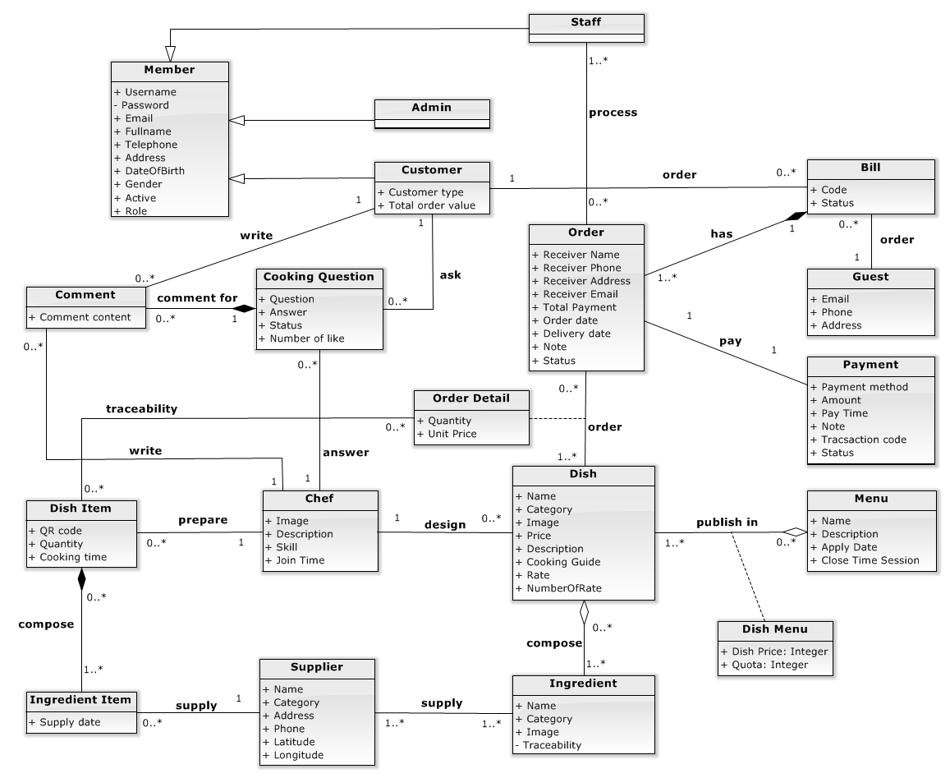
Figure 2 Entity Relationship Diagram

